JAVA

java collection :

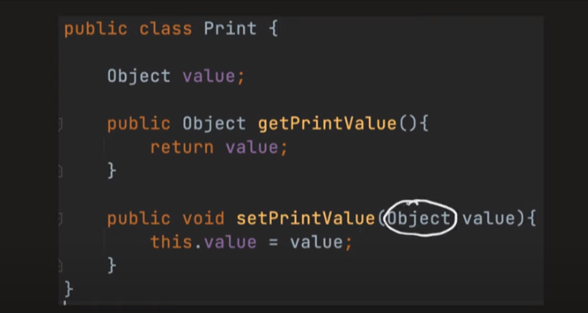

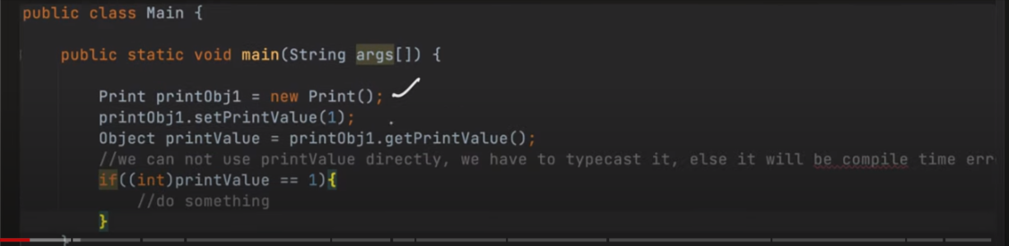

1.making our own genric class template

import java.util.*;

class OurGenericClass<T> {

    private T[] items;

    private *int* size;

    public OurGenericClass() {

        this.size = 0;

        items = (T[]) new Object[100];

    }

    public *void* add(T *item*) {

        items[size++] = *item*;

    }

    public T getItems(*int* *index*) {

        return items[*index*];

    }

}

public class SecondClass {

    public static *void* main(String *arg*[]) {

        OurGenericClass<Integer> list = new OurGenericClass<Integer>();

        list.add(1);

        list.add(1);

        list.add(1);

        System.out.println(list.getItems(0));

    }

};

2. to make genric class iterable we need to add ahead of our genric class : implement Iterable<T>

import java.util.*;

class OurGenericList<T> implements Iterable<T> {

    private T[] items;

    private *int* size;

    public OurGenericList() {

        this.size = 0;

        items = (T[]) new Object[100];

    }

    // defining iterator

    public Iterator<T> iterator() {

        return new OurGenericListIterator(this);

    }

    private class OurGenericListIterator implements Iterator<T> {

        private OurGenericList<T> list;

        private *int* index = 0;

        public OurGenericListIterator(OurGenericList<T> *list*) {

            this.list = *list*;

        }

        public *boolean* hasNext() {

            return index < list.size;

        }

        @*Override*

        public T next() {

            return list.items[index++];

        }

    }

    public *void* add(T *item*) {

        items[size++] = *item*;

    }

    public T getItems(*int* *index*) {

        return items[*index*];

    }

}

public class SecondClass {

    public static *void* main(String *arg*[]) {

        OurGenericList<Integer> list = new OurGenericList<Integer>();

        list.add(1);

        list.add(1);

        list.add(1);

        // Iterator<Integer> iterator=list.iterator();

        // while(iterator.hasNext()){

        // System.out.println(iterator.next());

        // }

        for (*int* i : list) {

            System.out.println(i);

        }

    }

};

🡺Genric class inheratance

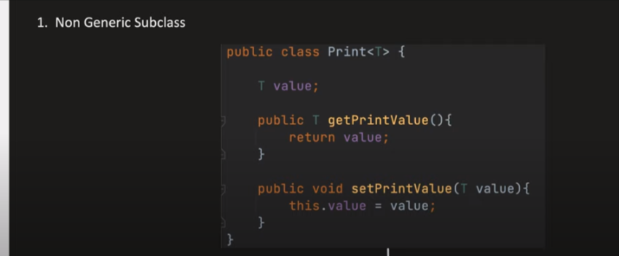

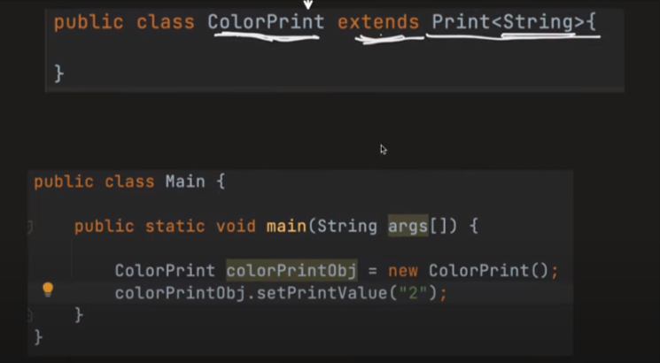

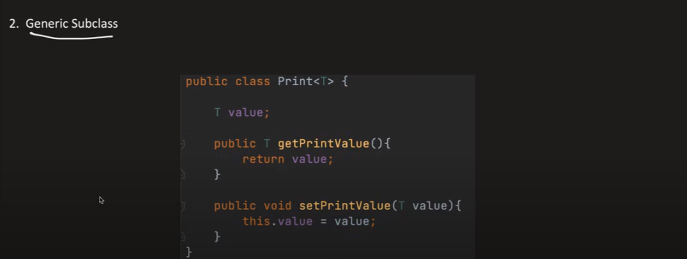

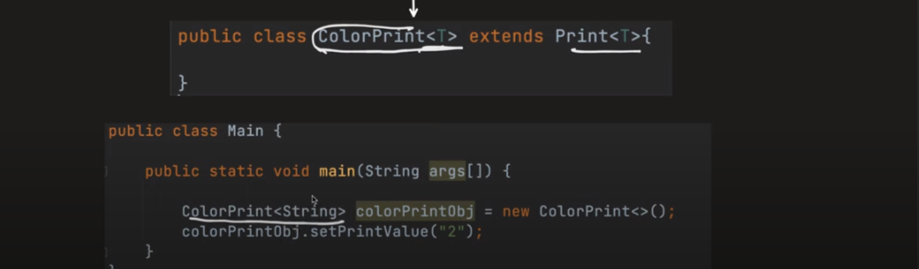

🡺More than one arrgument genric class :

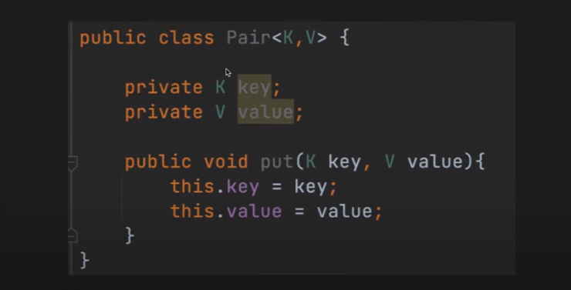

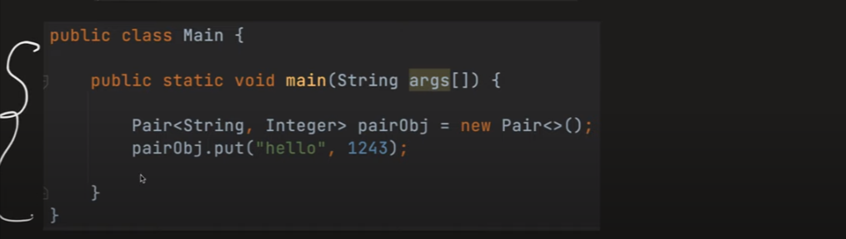

🡺What if we have to create only genric method :

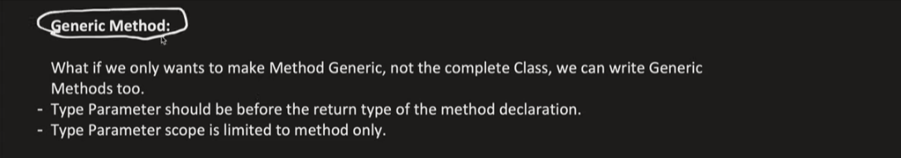

package com.strategy.design.pattern;

public class Method {

public <T> void print(T obj) {

System.***out***.println(obj);

}

}

🡺Raw Type

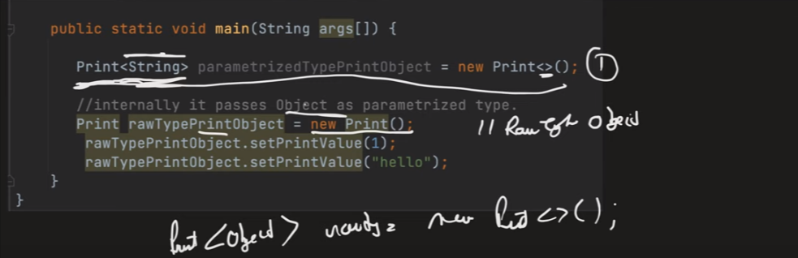

🡺Bounded Genric

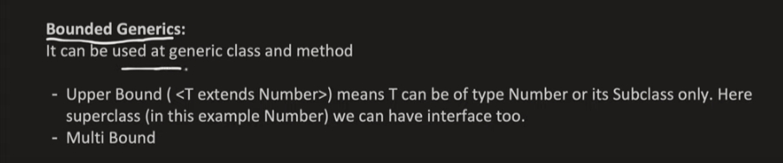

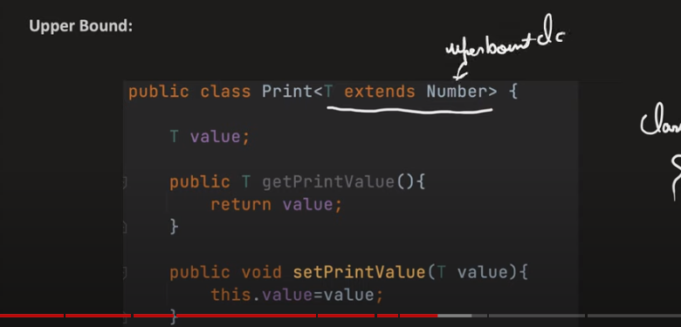



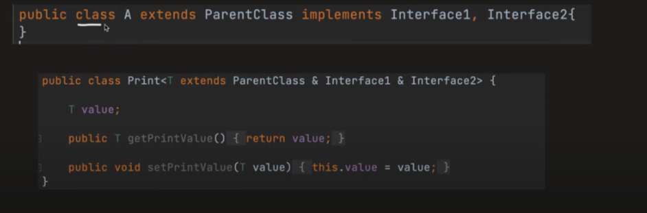

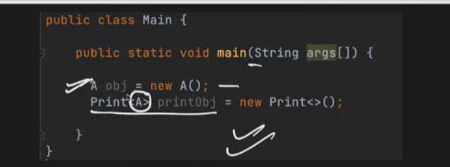

🡺WildCard Method



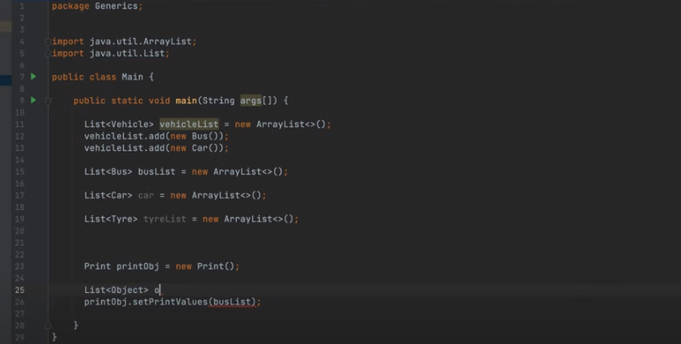

Upper Bound WildCard :

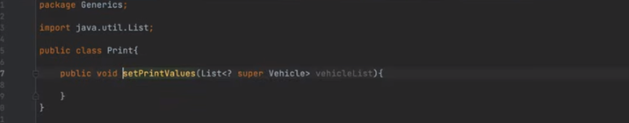

Lower Bound Wild Card :

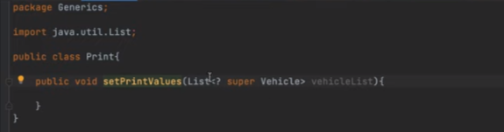

🡺Diffrence between genric Metod and WildCard Method :

i)in geric method we can have only upper bound but n wild card we can have upper bound lower bond

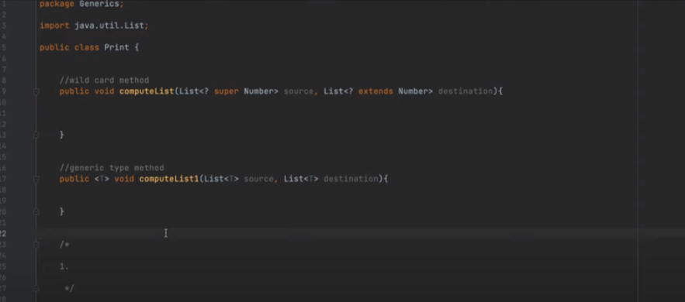

Type Eraser :

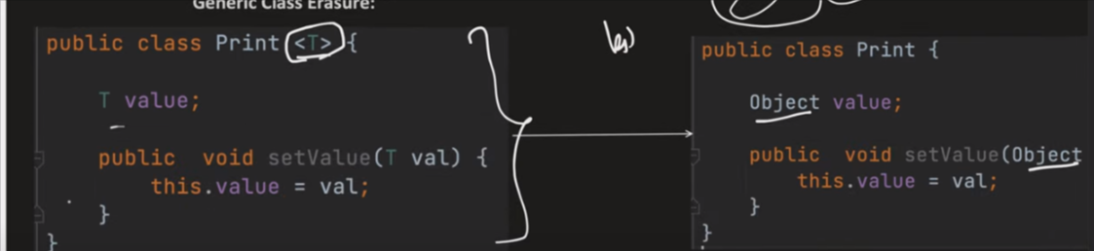

Genral method :

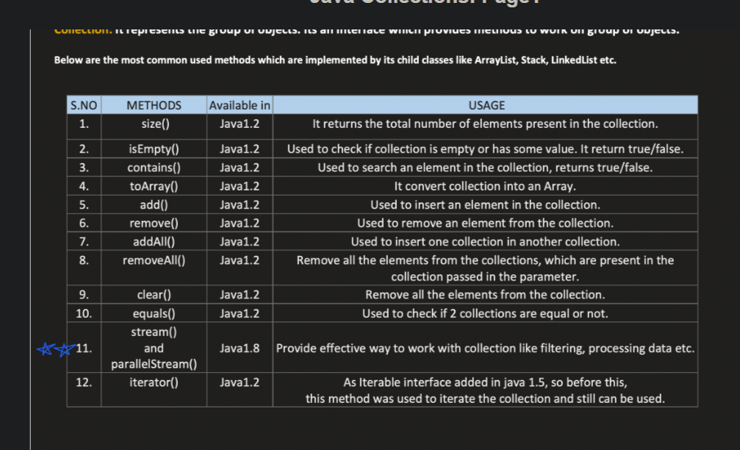

**COLLECTION HERIRCHY**

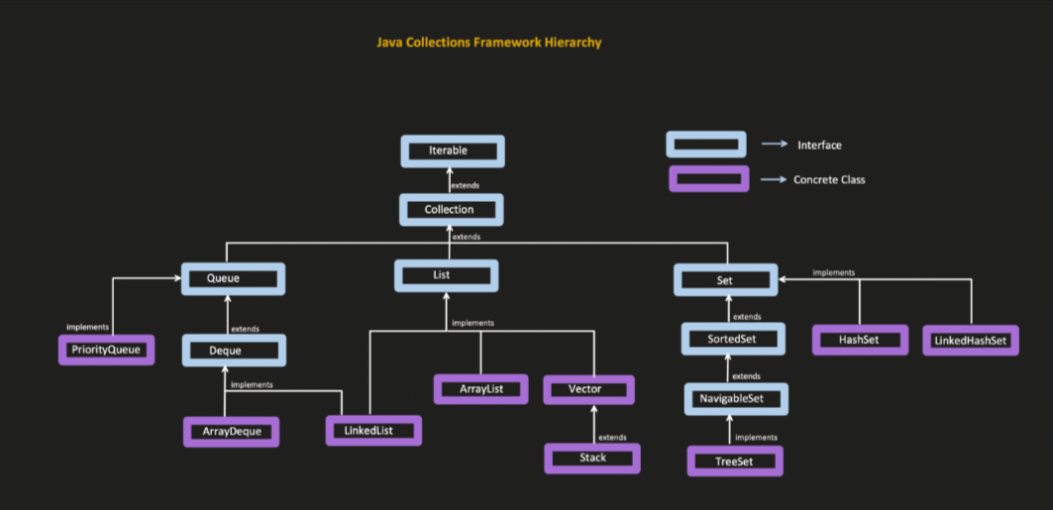

**1.ITERABLE INTERFACE**

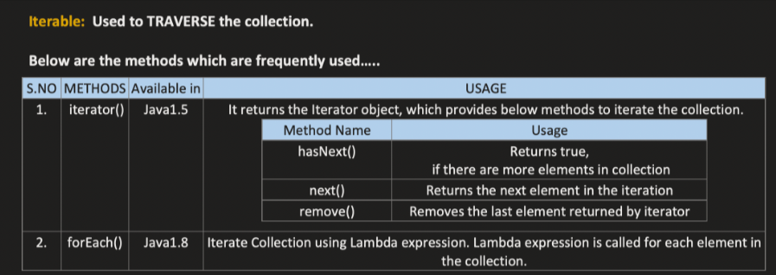

**2.Collection and Collections**

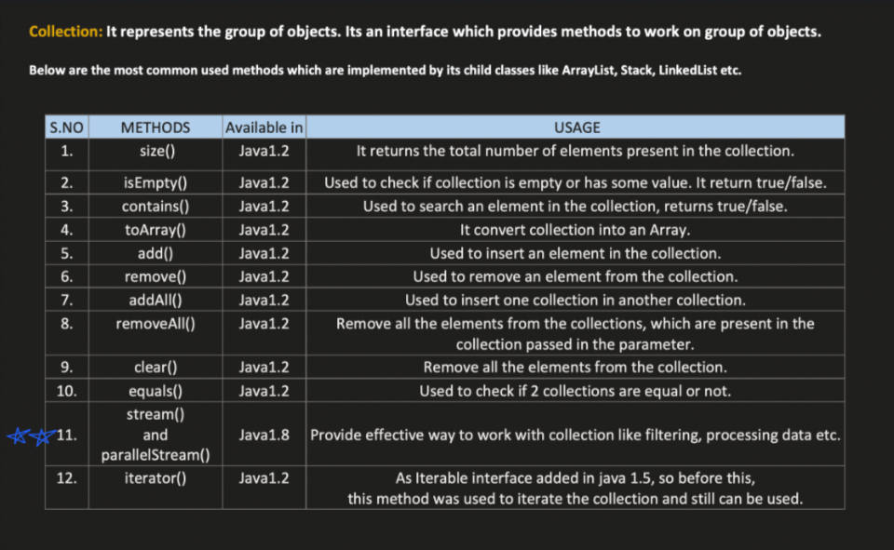

**Remove method of collection :**

**1.remove(3):it will going to remove the value at index 3**

**2.remove(Integer.valueof(3)):it will going to remove the 3 value inside the collection**

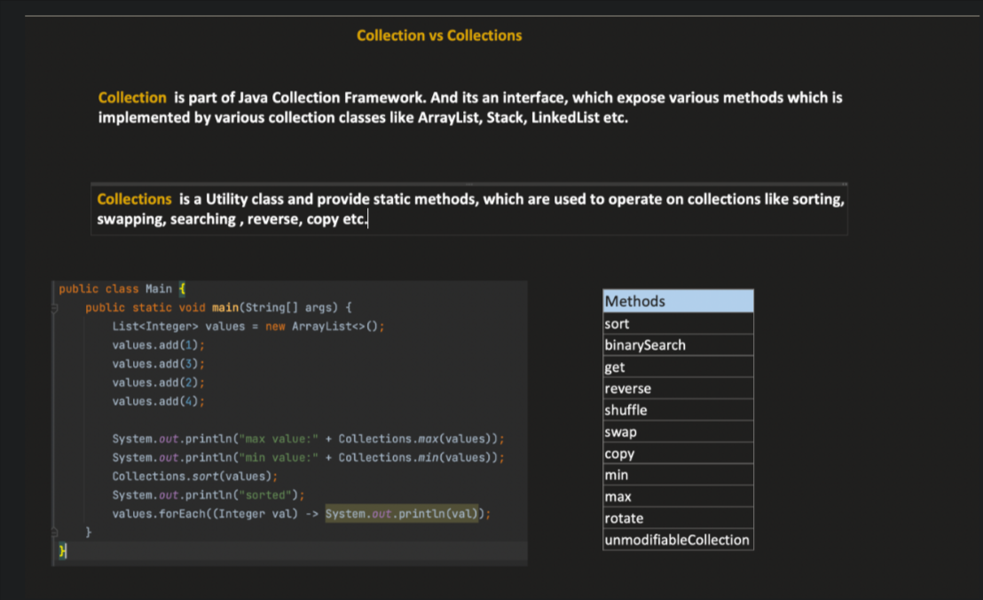

* LIST

1.List interface

A)ArrayList B)LinkedList (doubly linked list) C)Vector

2.List Iterator

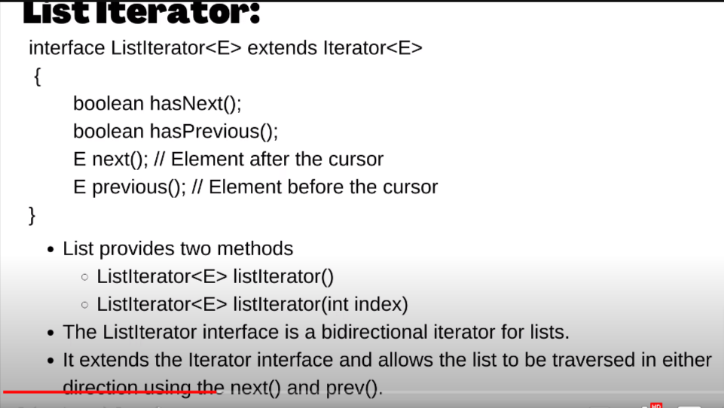

// Iterator<Integer> iterator=list.iterator();

        // while(iterator.hasNext()){

        // System.out.println(iterator.next());

        // }

 // Incase of iterator

        // next return list[index++];

        // prev return [--index];

1.ArrayList method

List<Integer> list = new ArrayList<>();

        // 1.add method

        list.add(1);

        list.add(2);

        list.add(3);

        // 2. print arr

        System.out.println(list);

        // 3. remove

        list.remove(1);

        // 4.size

        System.out.println(list.size());

        // 5.get element at particular size

        System.out.println(list.get(0));

        // 6.set element

        System.out.println(list.set(0, 5));

        // 7. Creating a copy

        List<Integer> CpyList = new ArrayList<>(list);

        System.out.println(CpyList);

        // 7.1 to create a array list with some element of last array

        List<Integer> sliceList = list.subList(0, 2); // will not

        // going to take the element at the last index

        // subList only take the reference of last array , so if we change any element in last array it will going to be change in Sublist

        // 8. to get the first occurrence of element in list

        System.out.println(list.indexOf(3));

        // 9.to get the last index

        System.out.println(list.lastIndexOf(3));

2.LinkedList

 List<Integer> list = new LinkedList<>();

        // 1.add method

        list.add(1);

        list.add(2);

        list.add(3);

        list.add(4);

        list.add(5);

        list.add(6);

        // all method of Array list

        /*

         *1.get 2.set 3.add 4.add(0,2) 5.addAll(list) 6. remove(index) 7.removeAll() 8.creating a cpy of LinkedList  9.subList 10.indexOf(value) 11.lastIndexOf

         12.print

         */

 // Incase of iterator

        // next return list[index++];

        // prev return [--index];

 // converting linked list to arr

        Integer arr[]=list.toArray(new Integer[0]);

        for(*int* i : arr){

            System.out.println(i);

        }

* QUEUES :

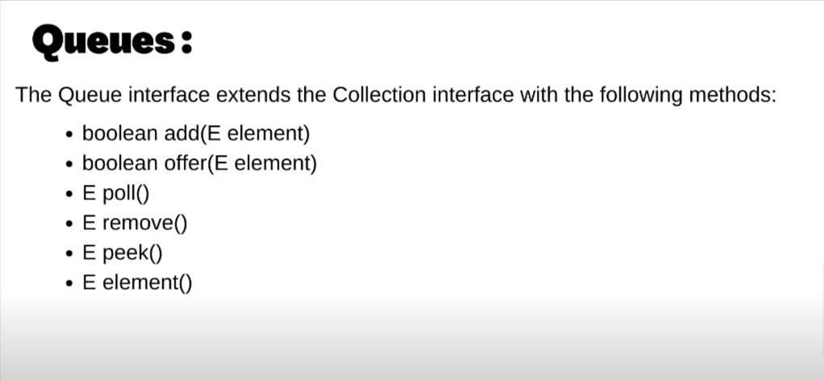

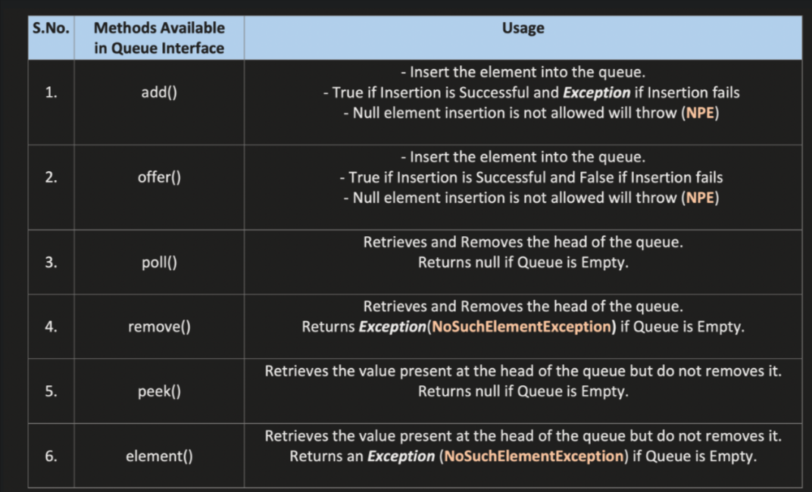

isEmpty : to check wheter it is empty or not

.size() : to find the size

diffrence between :

i)add VS offer :

add- do not give any error or exception if we will not be able to add element

offer- give exception if operation failed (most prefered)

ii)pool VS remove :

pool : donot show any exception when operation falied

remove : donot show any exception when operation falied

iii)peek vs element :

peek : do not give exception if there will be no top element

element: give exception

* DEQUE :

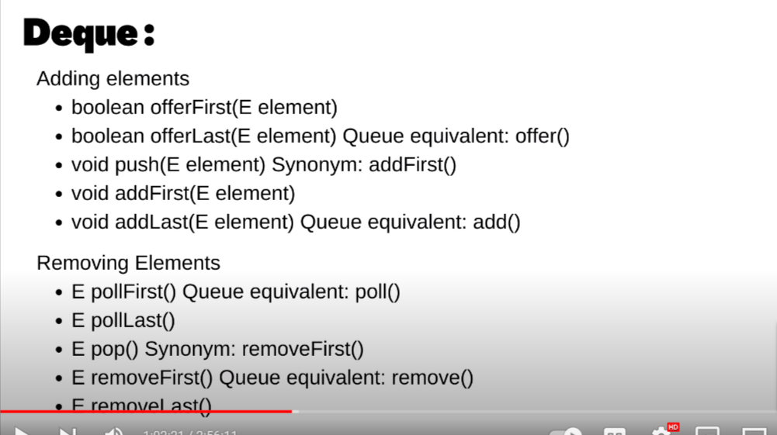

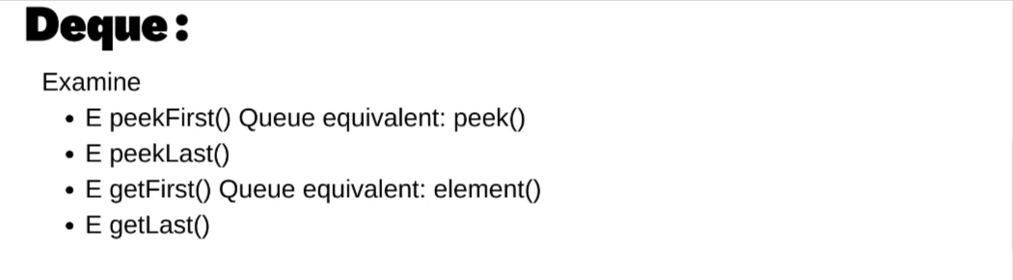

note :

i)FOR QUEUE WE use LinkedList interface of QUEUE

ii)FOR STACK WE use DEQUEUE interface of QUEUE

Queue implementation using LinkedList interface :

Queue<Integer> queue = new LinkedList<>();

        Scanner sc = new Scanner(System.in);

*int* n = sc.nextInt();

        for (*int* i = 0; i < n; i++) {

            queue.offer(sc.nextInt());

        }

        while (!queue.isEmpty()) {

            System.out.println(queue.peek());

            queue.remove();

        }

Stack implementation :

Stack<Integer> st = new Stack<>();

        Scanner sc = new Scanner(System.in);

*int* n = sc.nextInt();

        for (*int* i = 0; i < n; i++) {

            // for pushing element

            st.push(sc.nextInt());

        }

        while (!st.isEmpty()) {

            // for top element

            System.out.println(st.peek());

            st.pop();

        }

        // for size

        System.out.println(st.size());

Deque implementation :

Deque<Integer> dq=new ArrayDeque<>();

        Scanner sc = new Scanner(System.in);

*int* n = sc.nextInt();

        for (*int* i = 0; i < n; i++) {

            // for pushing element

            dq.offerFirst(sc.nextInt());

            dq.offerLast(sc.nextInt());

        }

        while (!dq.isEmpty()) {

            // for top element

            System.out.println(dq.peek());

            dq.pop();

        }

        // for size

        System.out.println(dq.size());

Comprable and comprator

diffrence :

i)comprable is natural oddering where as comprator is total odering

ii)comprable compare interface should be implemented by class itself where as comprator interface should be implemented by taking two object of class

ii)while implementing comprable interface we have to implement compareTo method where as to implement Comprator interface we have to implement compare method

implementation useing comprable :

import java.util.*;

 class Student implements Comparable<Student>{

    public *int* math;

    public *int* physics;

    public Student(*int* *math*,*int* *physics*){

        this.math=*math*;

        this.physics=*physics*;

    }

    @*Override*

    public *int* compareTo(Student *s*){

        return *s*.math -this.math;

    }

};

public class SecondClass {

    public static *void* main(String *arg*[]) {

        PriorityQueue<Student> pq = new PriorityQueue<>();

        Scanner sc = new Scanner(System.in);

*int* n = sc.nextInt();

        for (*int* i = 0; i < n; i++) {

            pq.offer(new Student(sc.nextInt(),sc.nextInt()));

        }

        while (!pq.isEmpty()) {

            Student st=pq.remove();

            System.out.println("Math : "+st.math + "Physics: "+st.physics);

        }

    }

};

IMPLEMENTATION OF COMPRATOR INTERFACE :

import java.util.*;

class Cmp implements Comparator<Integer> {

    @*Override*

    public *int* compare(Integer *a*, Integer *b*) {

        return *a* - *b*;

    }

};

public class SecondClass {

    public static *void* main(String *arg*[]) {

        PriorityQueue<Integer> pq = new PriorityQueue<>(new Cmp());

        Scanner sc = new Scanner(System.in);

*int* n = sc.nextInt();

        for (*int* i = 0; i < n; i++) {

            pq.offer(sc.nextInt());

        }

        while (!pq.isEmpty()) {

            System.out.println(pq.remove());

        }

    }

};

* PRIORITY QUEUE :

// Minheap

PriorityQueue<Integer> pq = new PriorityQueue<>();

        Scanner sc = new Scanner(System.in);

*int* n = sc.nextInt();

        for (*int* i = 0; i < n; i++) {

            pq.offer(sc.nextInt());

        }

        while (!pq.isEmpty()) {

            System.out.print(pq.remove());

        }

// Max heap

 Comparator<Integer>cmp=new Comparator<Integer>() {

            public *int* compare(Integer *n1*,Integer *n2*){

                // if(n1<n2){

                //     return 1;

                // }

                // else if(n1>n2){

                //     return -1;

                // }

                // else{

                //     return 0;

                // }

                return *n2*-*n1*;

            }

        };

        PriorityQueue<Integer> pq = new PriorityQueue<>(cmp);

        Scanner sc = new Scanner(System.in);

*int* n = sc.nextInt();

        for (*int* i = 0; i < n; i++) {

            pq.offer(sc.nextInt());

        }

        while (!pq.isEmpty()) {

            System.out.print(pq.remove());

        }

SET :

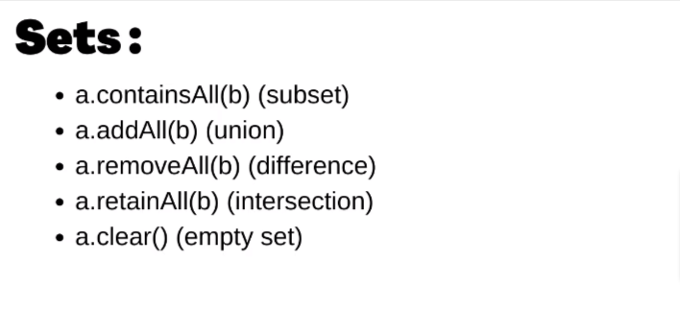

1.to add element : use set.add(element);

2.to remove element use : set.remove(element)

3.To check a element is present or not : set.contain(element)

3. to get the size : set.size();

4.for traversal : for(int i:set){}

1.hasset (unordered_Set in c++)

  Set<Integer> set = new HashSet<>();

        Scanner sc = new Scanner(System.in);

*int* n = sc.nextInt();

        for (*int* i = 0; i < n; i++) {

            set.add(sc.nextInt());

        }

        System.out.print(set);

    }

note :in hashset insertion ordered is not retain element will be in sorted order to maintain order we can use linkHashSet

2.LinkHashSet

 Set<Integer> set = new LinkedHashSet<>();

        Scanner sc = new Scanner(System.in);

*int* n = sc.nextInt();

        for (*int* i = 0; i < n; i++) {

            set.add(sc.nextInt());

        }

        System.out.print(set);

* wrong ans in

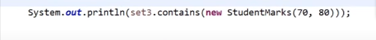

because :

1)



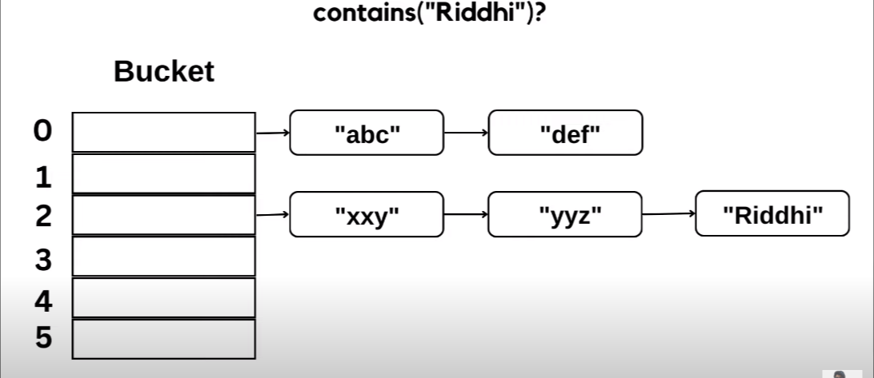

so , when we are calling contains method then it find the hasconde crosspounding to that hash code it get bucket index no , but we have’nt implemented the hascode and equall method to override the existing method of hasSet.

import java.util.*;

class Student {

    private *int* math;

    private *int* physics;

    public Student(*int* *math*, *int* *physics*) {

        this.math = *math*;

        this.physics = *physics*;

    }

    // implementing hashCode

    @*Override*

    public *int* hashCode() {

         final *int* prime = 31;

*int* result = 1;

        result = prime * result + math;

        result = prime * result + physics;

        return result;

    }

    // implementing equal

    public *boolean* equals(Object *obj*) {

        if (this == *obj*) {

            return true;

        }

        if (*obj* == null) {

            return false;

        }

        if (getClass() != *obj*.getClass()) {

            return false;

        }

        // typecasting the obj

        Student other = (Student) *obj*;

        if (math != other.math) {

            return false;

        }

        if (physics != other.physics) {

            return false;

        }

        return true;

    }

};

public class SecondClass {

    public static *void* main(String *arg*[]) {

        Set<Student> set = new HashSet<>();

        Scanner sc = new Scanner(System.in);

*int* n = sc.nextInt();

        for (*int* i = 0; i < n; i++) {

            set.add(new Student(sc.nextInt(), sc.nextInt()));

        }

        System.out.print(set.contains(new Student(56, 56)));

    }

};

3.TreeSet (set in c++)

NavigableSet : inteface

NavigableSet<Integer>set=new TreeSet<>();

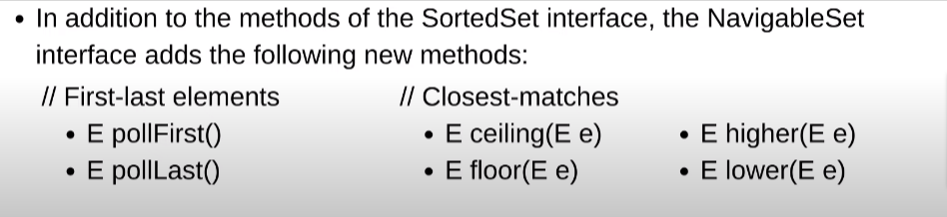

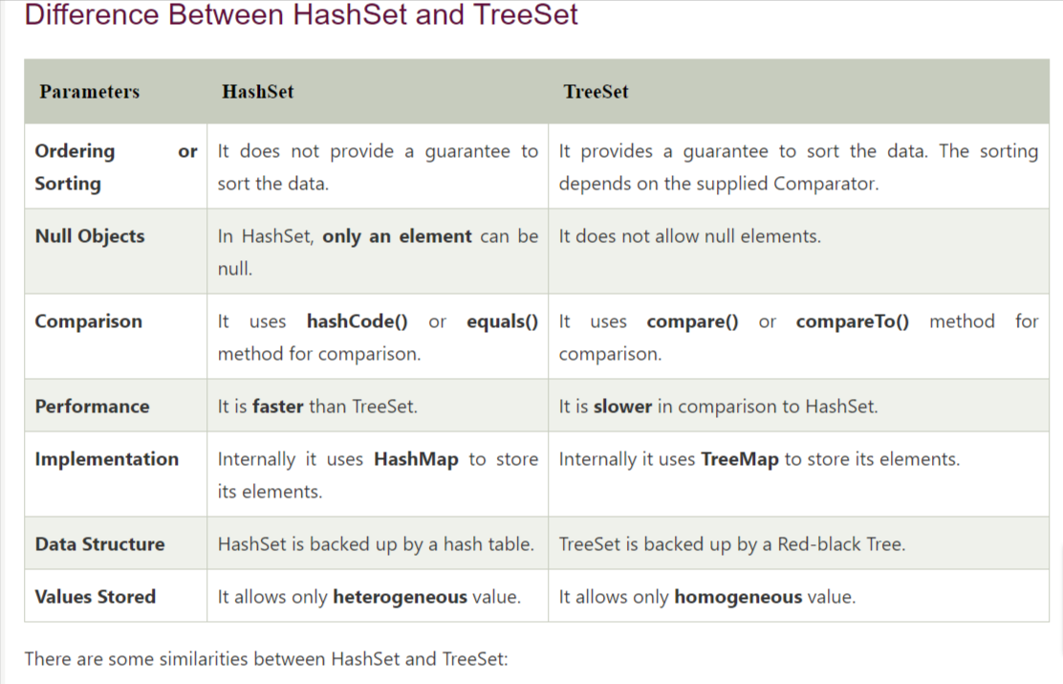

Map : map are not iterable

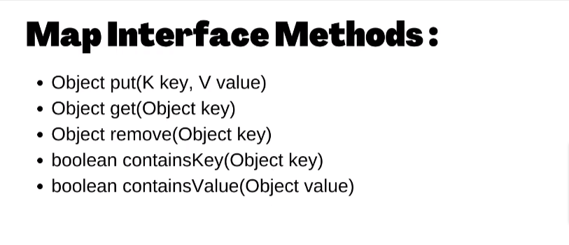

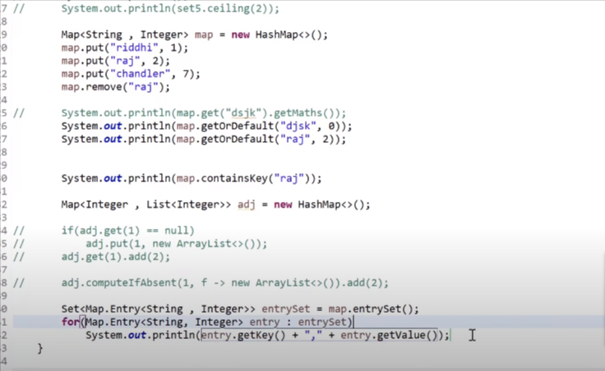

HashTree

Lamda fuction

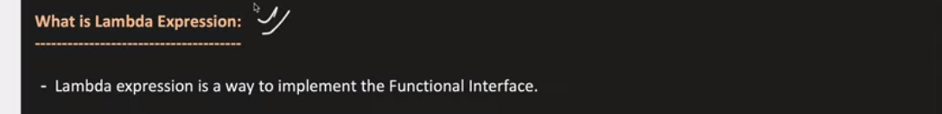

1.passing function in java

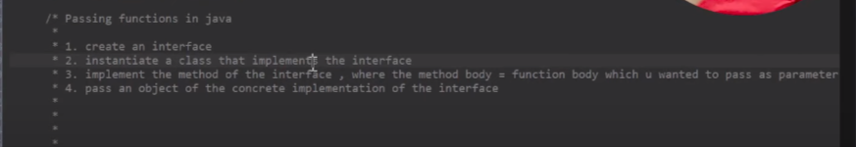

a)creating interface : filterCondition.java

package Interface;

public interface FiltringCondition {

abstract void print();

b)creating a class which will going to implement method of interface

package My_package;

import Interface.FiltringCondition;

public class Cat implements FiltringCondition {

private String name;

private int age;

public Cat() {};

public void print() {

System.***out***.println("meow");

}

}

c)creating a function

public static void printable(FiltringCondition Things) {

Things.print();

* Anonymous Inner Class
* package My_package;
* import java.util.*;
* import Interface.FiltringCondition;
* public class Myclass {
* public static boolean printable(FiltringCondition Things,int a) {
* return Things.print(a);
* }
* public static void main(String arg[]) {
* boolean ans=*printable*(new FiltringCondition(){
* public boolean print(int a) {
* return a%2!=0;
* }
* },8);
* System.***out***.println(ans);
* }
* }
* lamda expression
* package My_package;
* import java.util.*;
* import Interface.FiltringCondition;
* public class Myclass {
* public static boolean printable(FiltringCondition Things,int a) {
* return Things.print(a);
* }
* public static void main(String arg[]) {
* boolean ans=*printable*((int a)->{
* return a%2!=0;
* },7);
* System.***out***.println(ans);
* }
* }

note : lamda expression convert the written pice of code into the anomyous inner class.

ii) while using lambda expression the intrface class should be with 1 method only othrewise it start giving error due to ambiguity because the labda expression implementing things using anomyous inner class .

iii)when using this with the lambda function ,the the this will point to the class inwhich lamba function is defined

iv)when we define a varibale in lambda expression theen we can not change the value of varible due to value capturing .

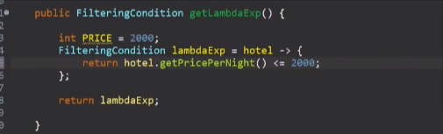

note : we can not change the Value of PRICE because of value capture .

* pedicate is built in java interface

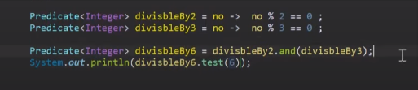

method :

1. .test();
2. .and();
3. .or()
4. package My_package;
5. import java.util.*;
6. import java.util.function.Consumer;
7. import Interface.FiltringCondition;
8. public class Myclass {
9. public static boolean printable(FiltringCondition Things,int a) {
10. return Things.print(a);
11. }
12. public static void main(String arg[]) {
13. List<Integer>list=new ArrayList<Integer>();
14. list.add(1);
15. list.add(2);
16. list.add(3);
18. Consumer<Integer> consumer= a->System.***out***.println(a);
20. list.forEach(consumer);
21. }

EXCEPTION HANDLING :

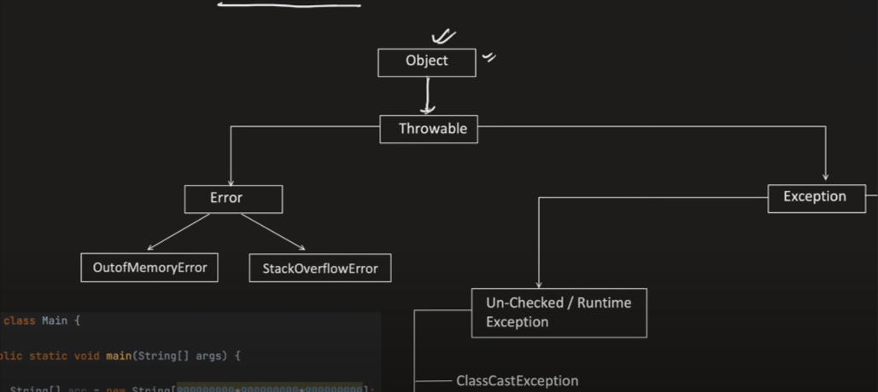

TYPE OF EXCEPTION –

1)CHECKED OR COMPILE TIME EXCEPTION

2)UNCHECKED OR RUN TIME EXCEPTION

Diffrence between error and excption :

Error : Erro are those throwable which we can not handle it is handle by jvm .

Excption : Exceptions are those throwable which we can handle .

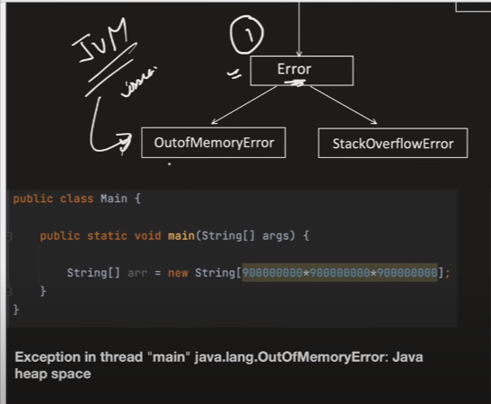

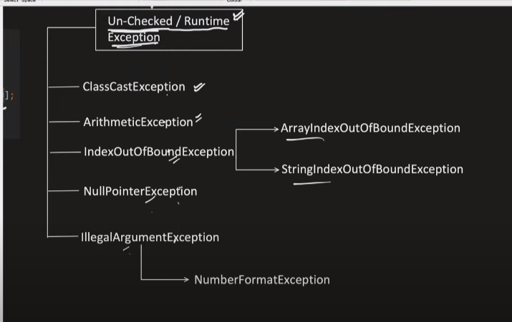

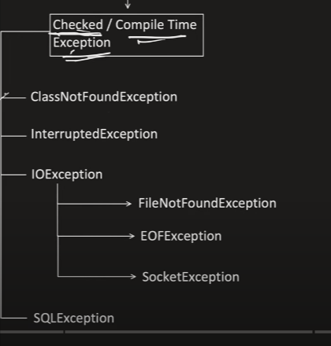

Exception stack trace :

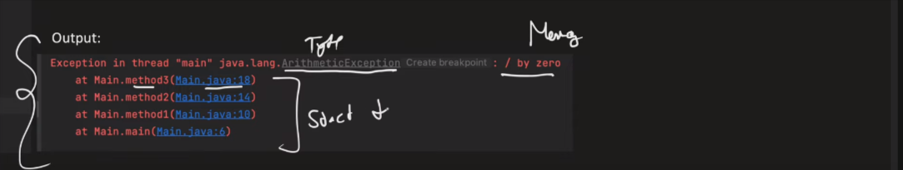

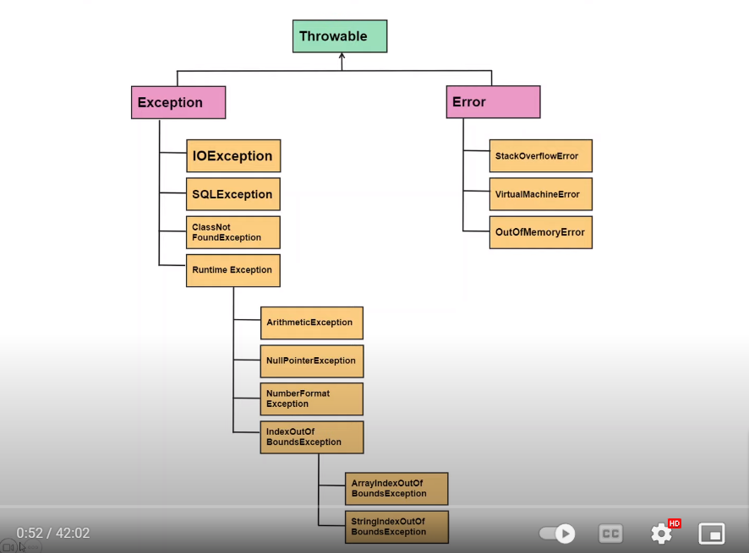

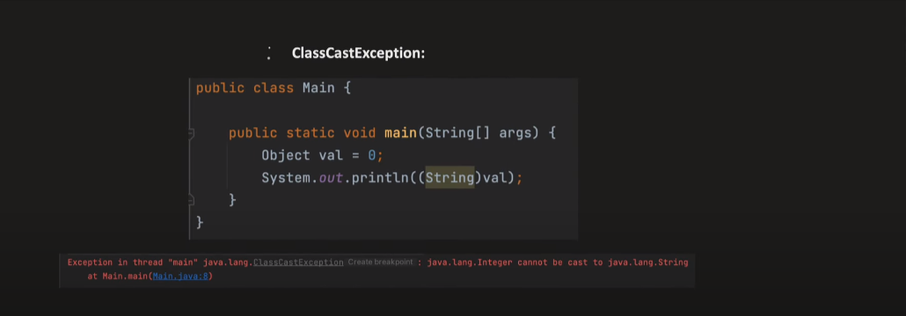

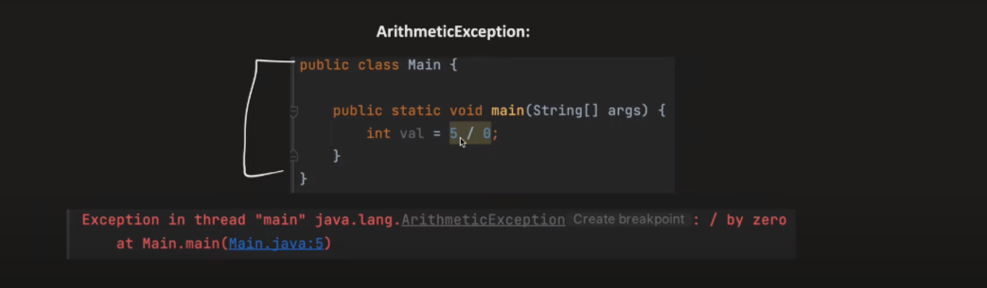

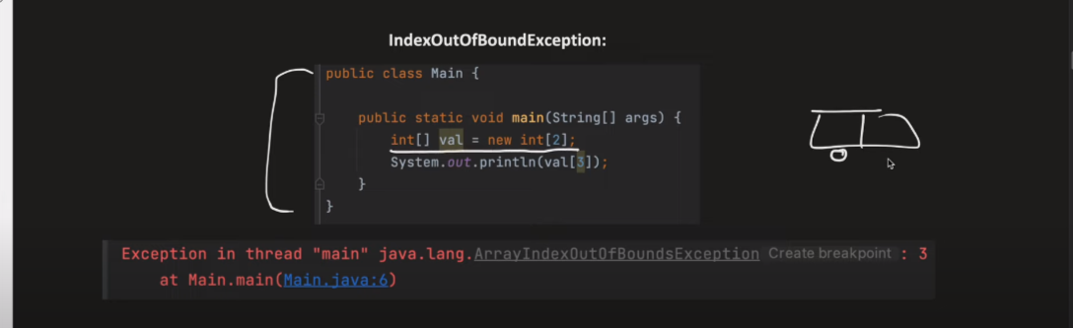

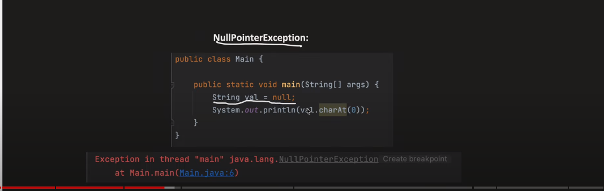

🡪Way to handdle null pointer exception

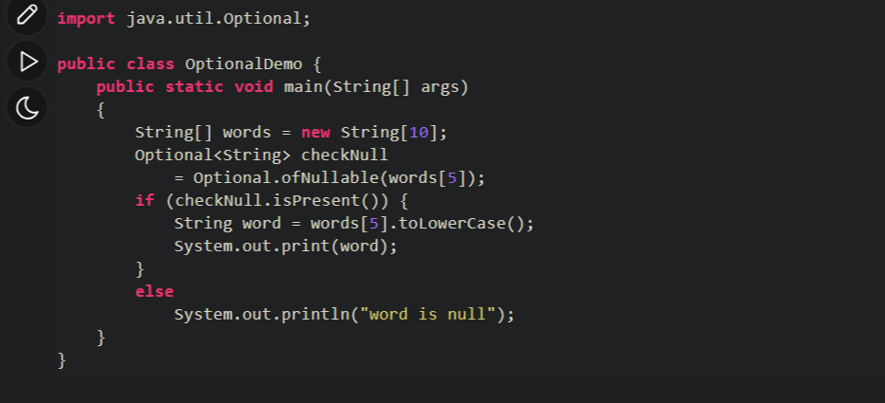

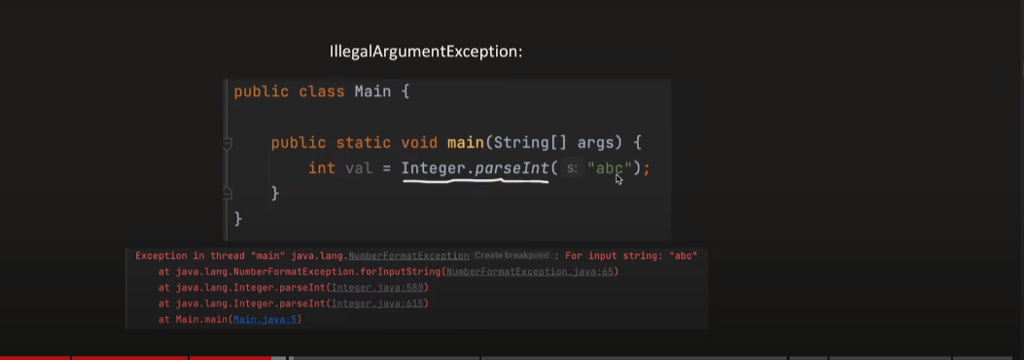

Exception Handling :

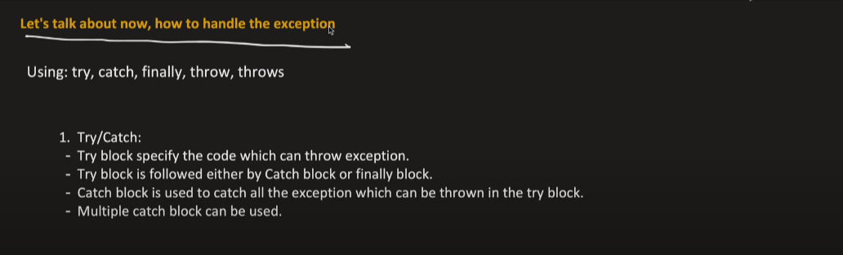

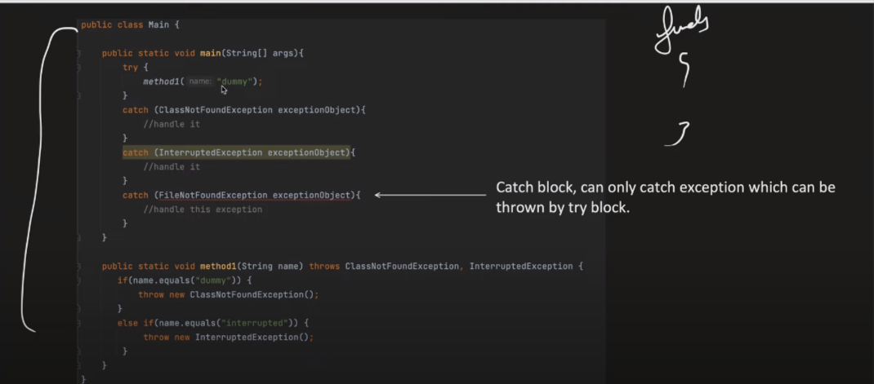

🡪Wrong way to handling exception :

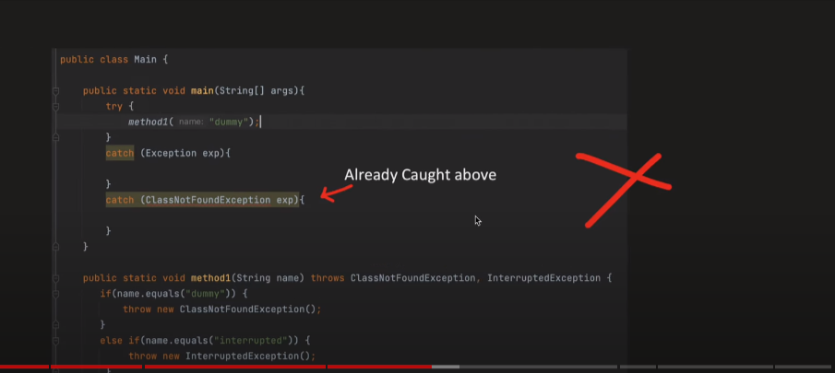

Because : Exception is parent of classNotFoundException so it is already handled

🡪Right way of handling Excepiton

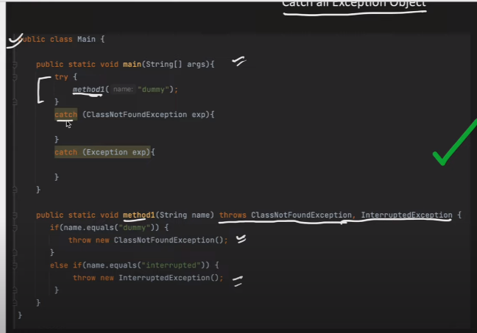

🡪Catching Multiple Exception

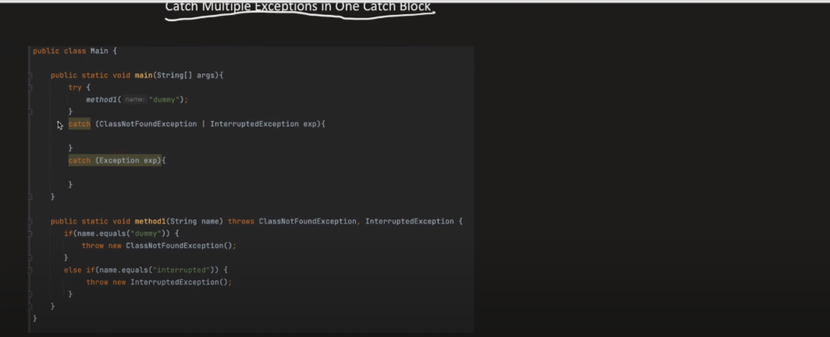

🡺Creating our own custom Exception

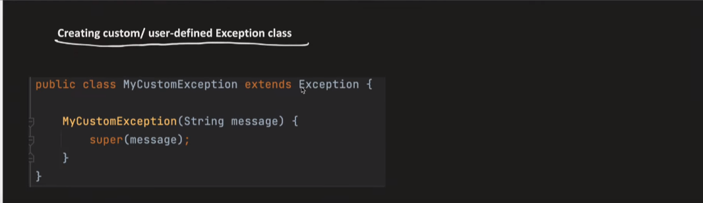

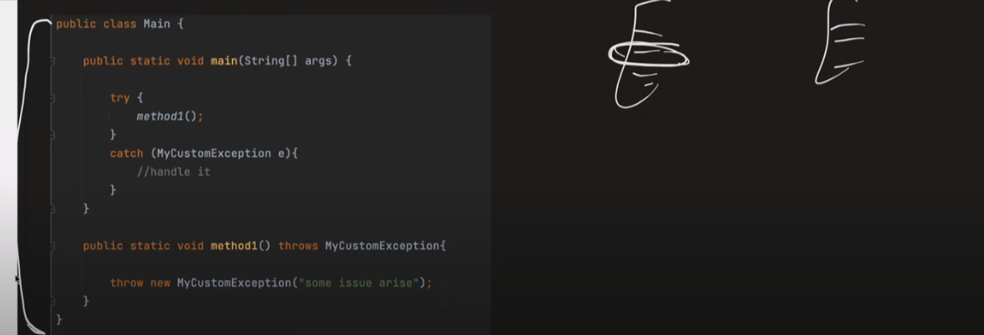

Disadvantages of exception handling :

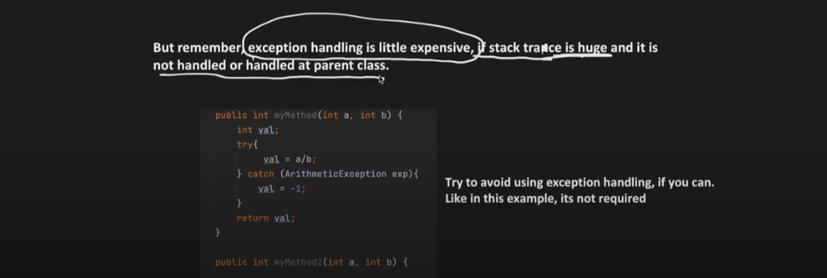

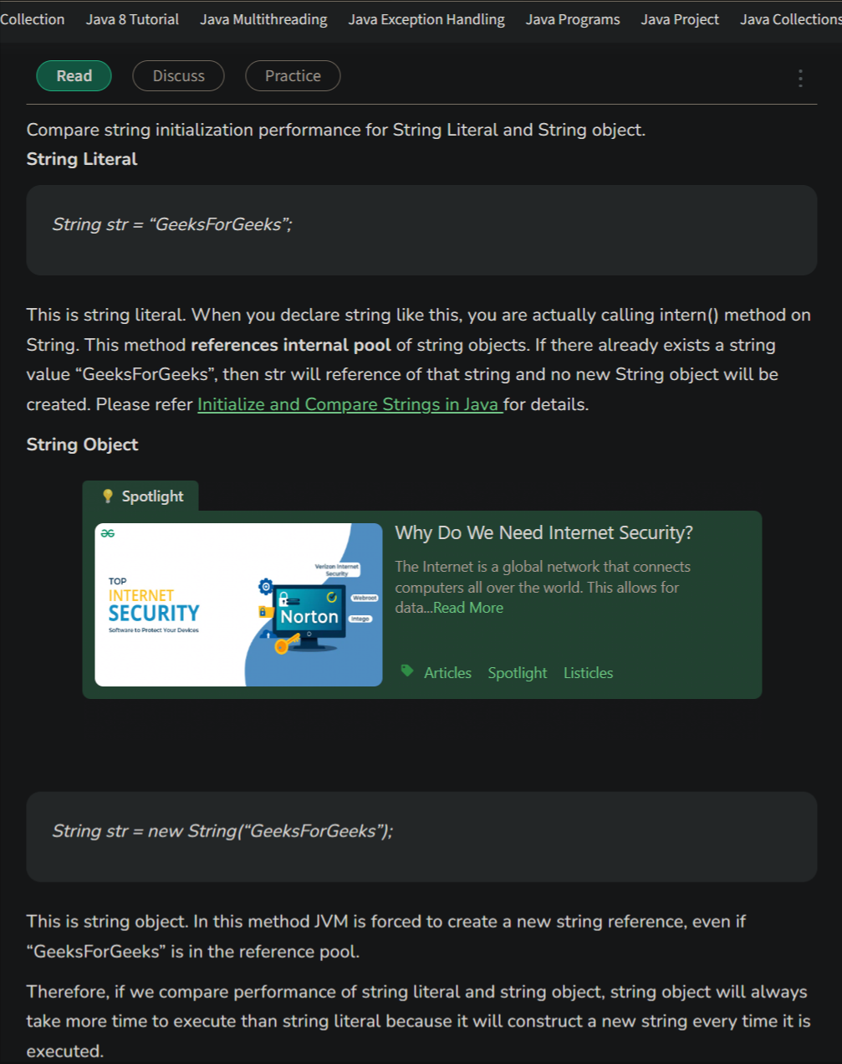

Memory Management and Grabge Collector :

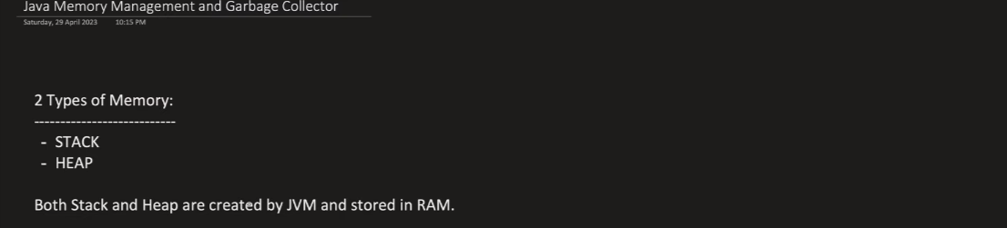

Stack memory : store object refrence

Heap Memory : store object valce

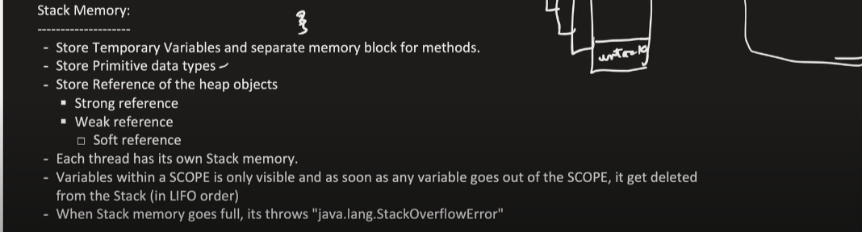

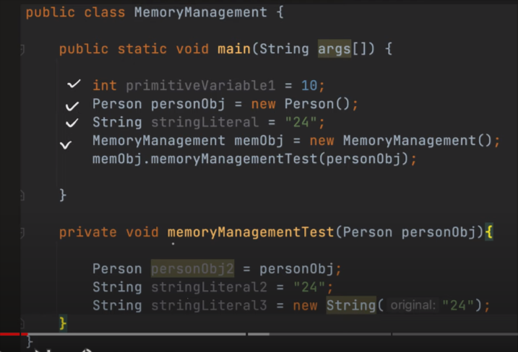

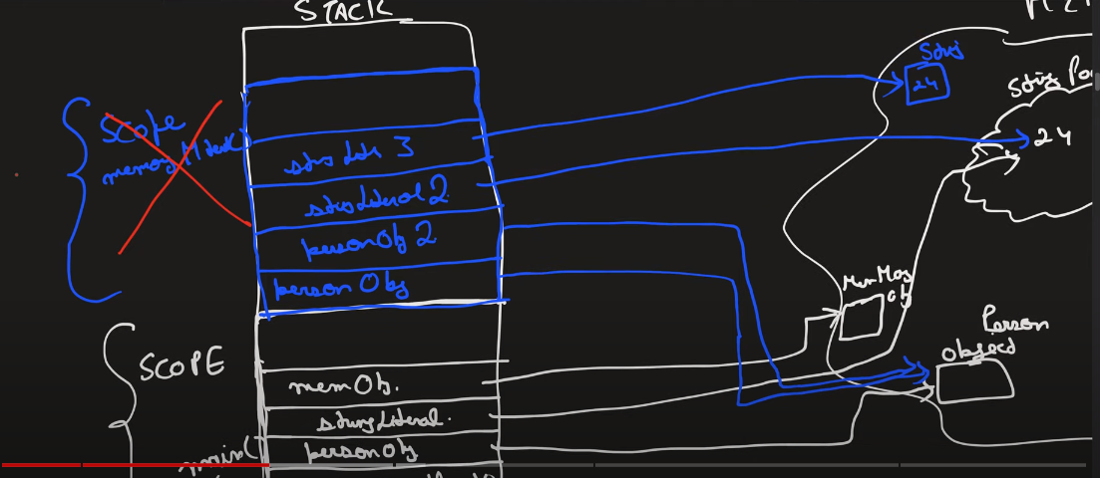

Note : Heap memroy is freed by grabge Collector that is control by JVM.

Stronge stack Refrence and Weak Stack Refrence :

i)Strong Stack Refrence : Person p1=new Person();

ii)Weak Stack Refrence :WeakRefrence<Person>p2=new WeakRefrence<>(new Person());

note : Strong object in heap will be going to remove by grabge collector only if there will be no refrence but weak object can be remove by grabge collection when it wants .

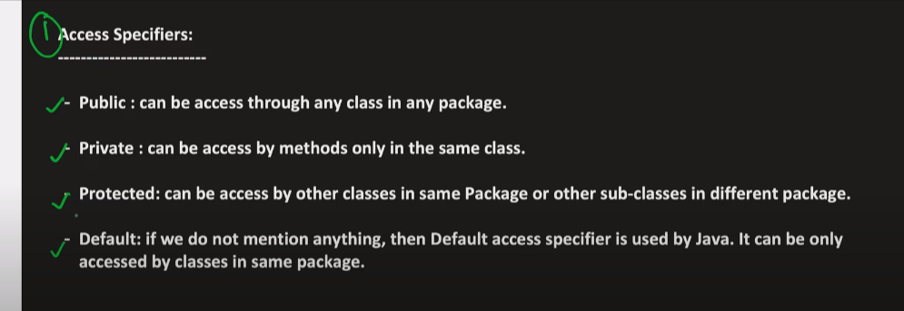

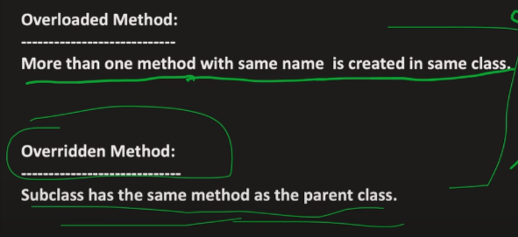

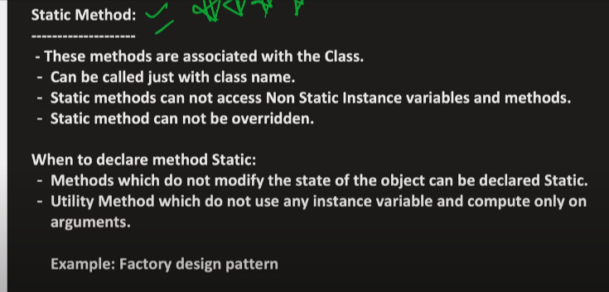

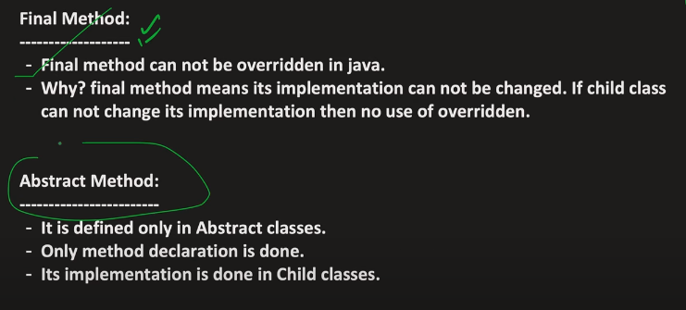

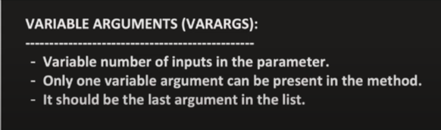

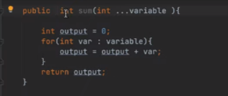

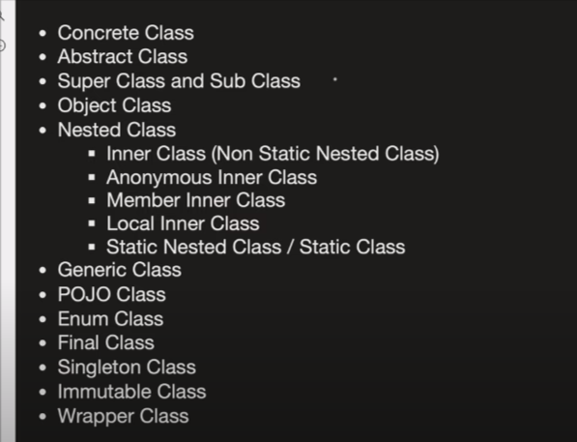

Similarity between abstract class and interface class :

1. Abstract class and interface class can be used to achive abstraction .
2. We can not create object of abstract class and interface class.

Diffrence between abstract class and interface class :

i)with abstract class the abstraction can will be (0-100%) but with interface class the abstraction will be (100%)

ii)in abstract class we can have constructor but in interface class we can not have constructor

iii)in abstract class we can have some implemented method but in interface we can not have implemented method .

iv)in abstract class we extend the child calss but in interface we implement child class.

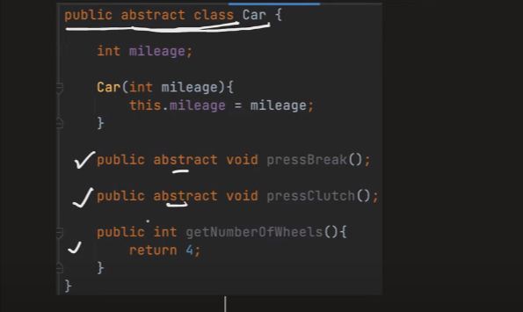

Note : we can not create object of absract class but we can create the refrence of absract class .

we can create the object of contrect class.

Note : to know which class this object belongs for that we can use : method ->

Object ojb=new class();

System.out.println(ojb.getClass());

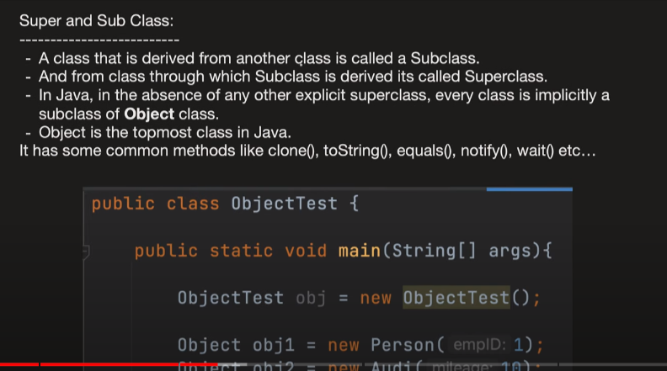

Nested class :

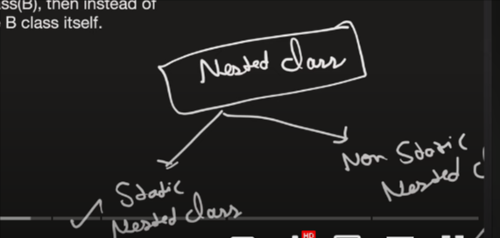 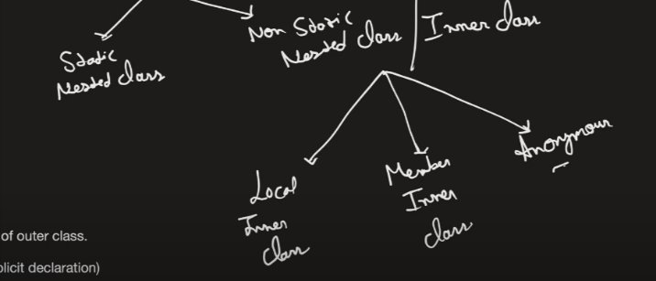

Note : nested classes can be of private/protected/public assess modifire

Static nestd calss :

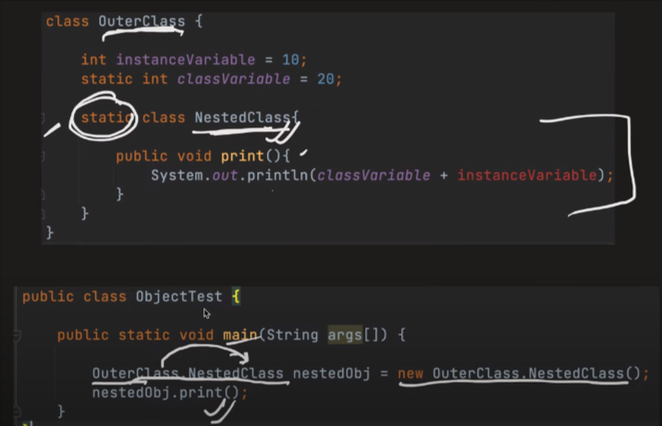

Non-static nested class or inner class :

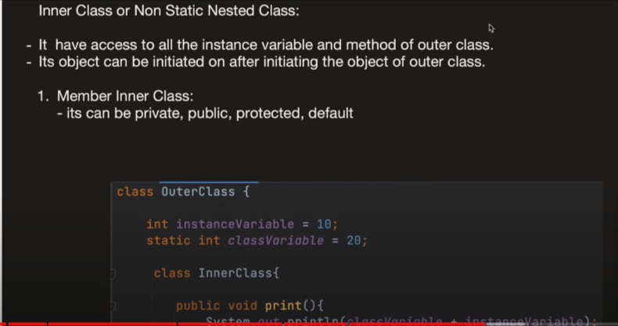 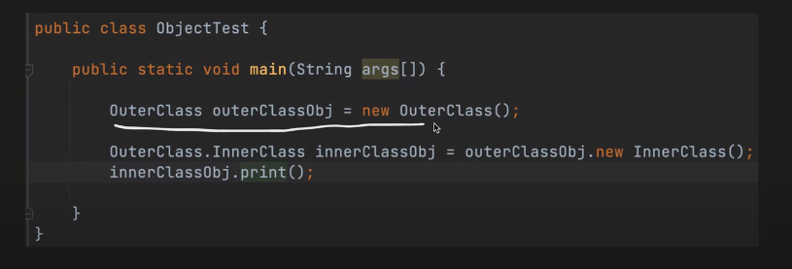

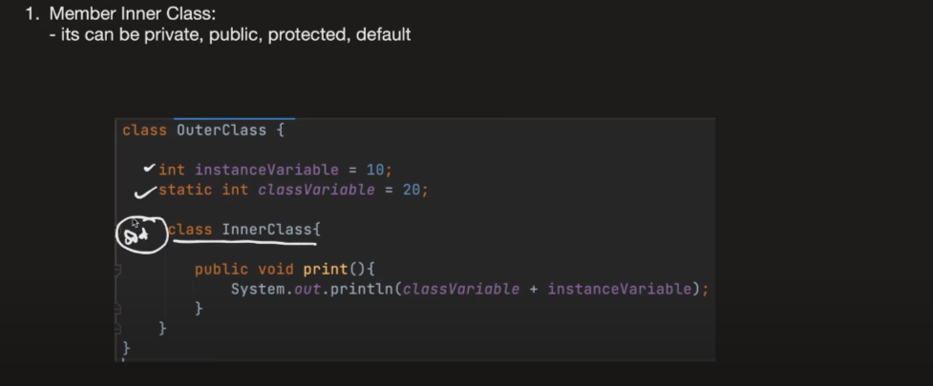

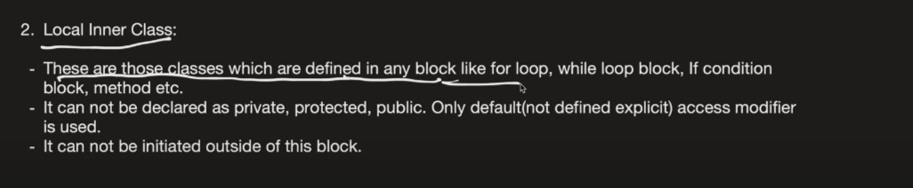

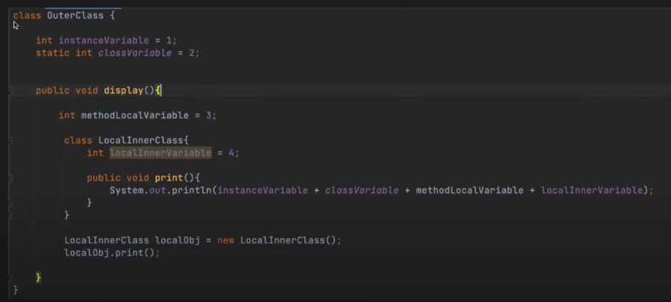

Inheritance in nested class :

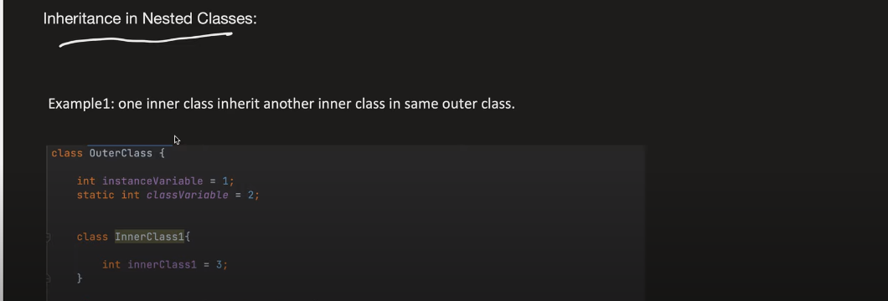

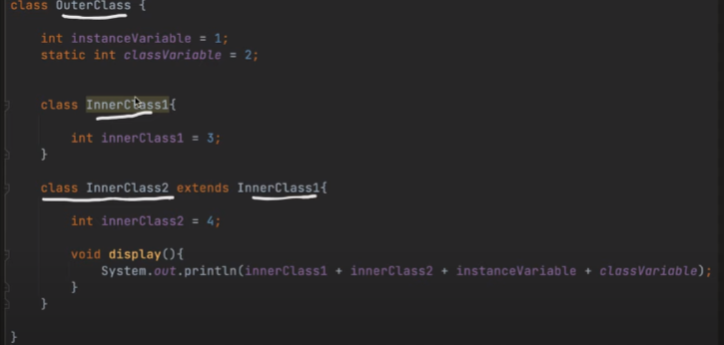

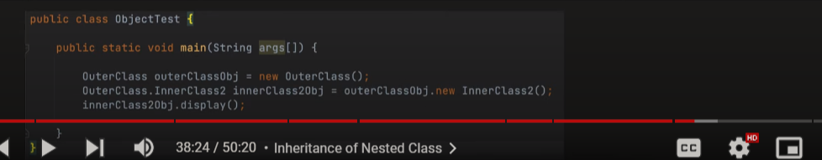

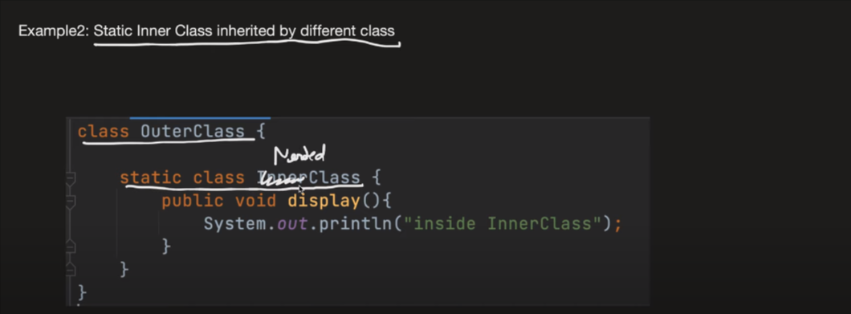

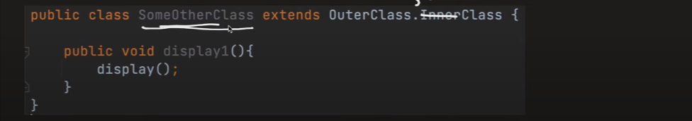

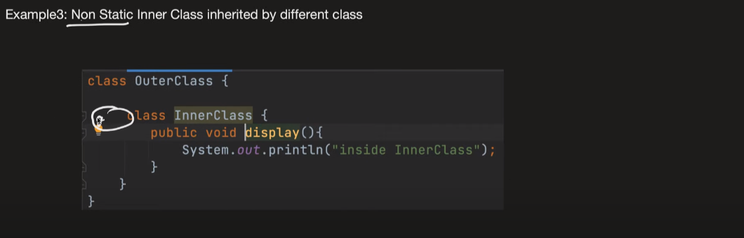

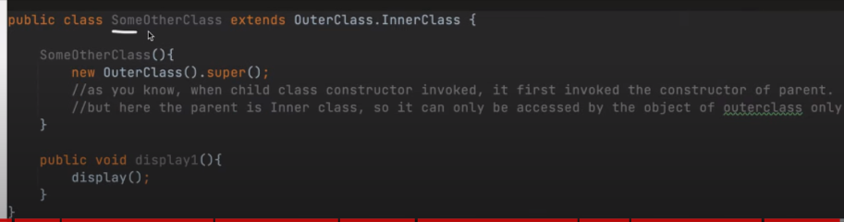

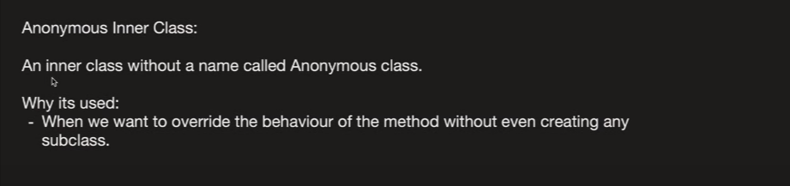

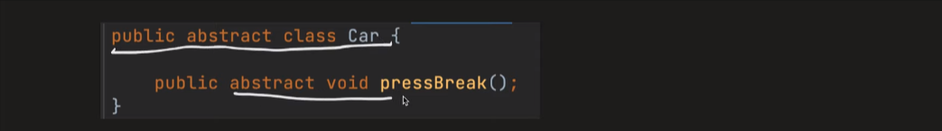

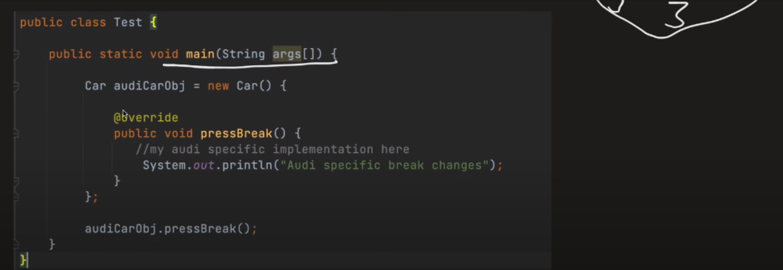

🡺POJO CLASS :

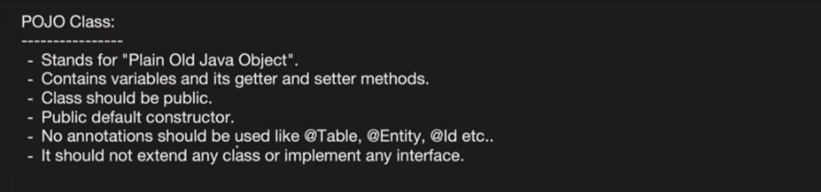

🡺ENUM CLASS :

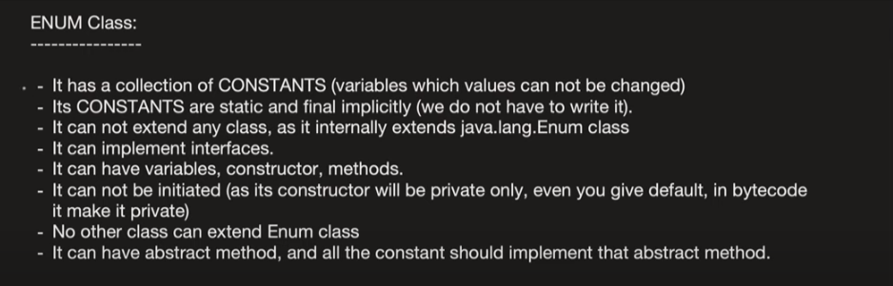

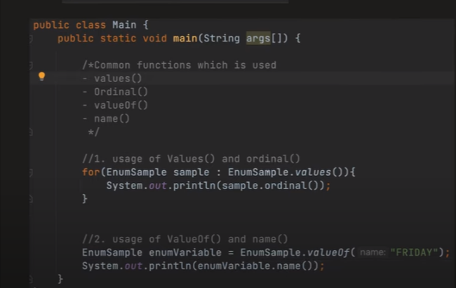

🡺Enum with custom value :

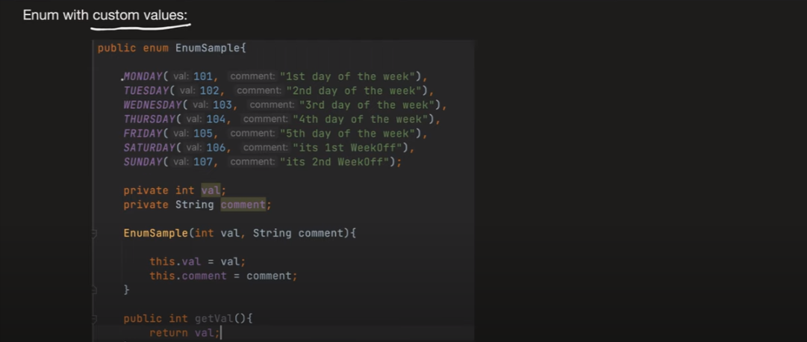

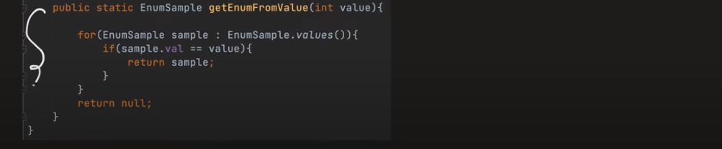

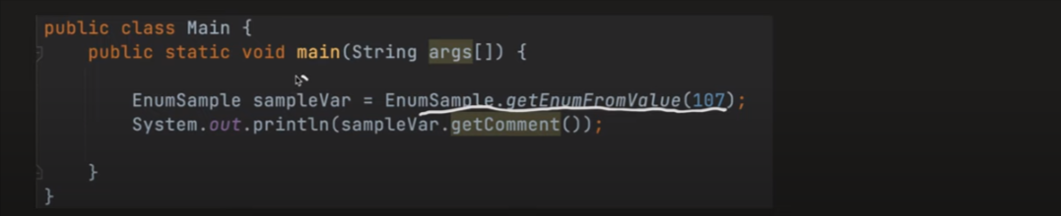

🡺Method overRiding in Enum :

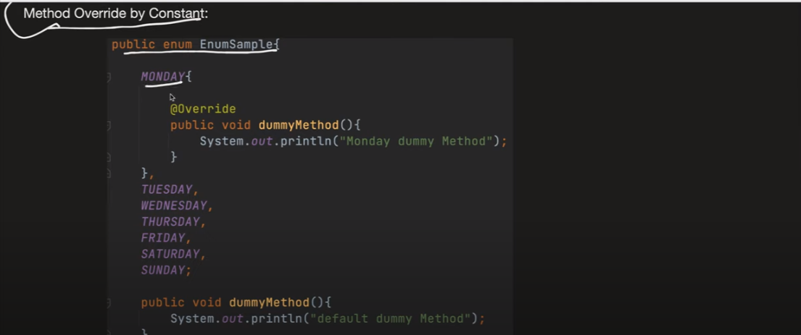

🡺Abract Method in Enum :

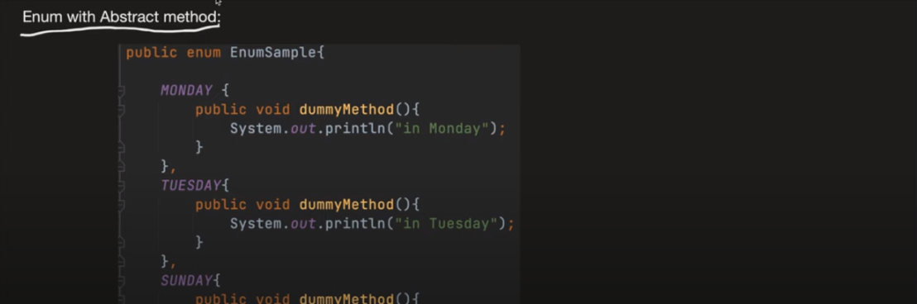



🡺Interface implementation in Enum :

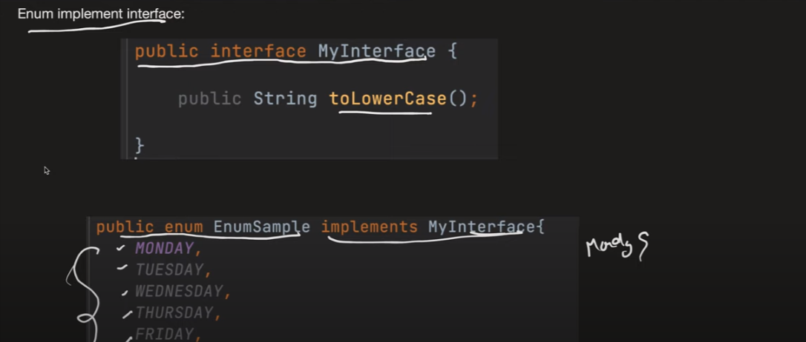

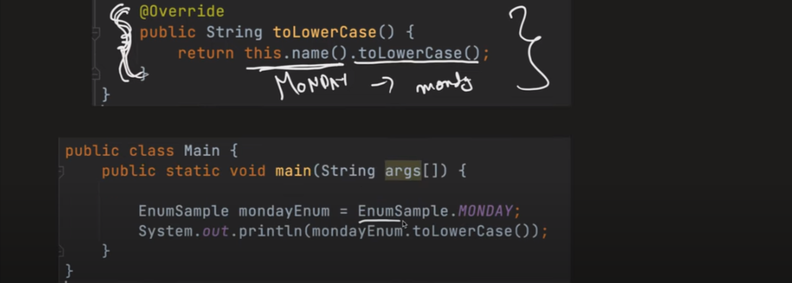

🡺Benfit of Enum over static final

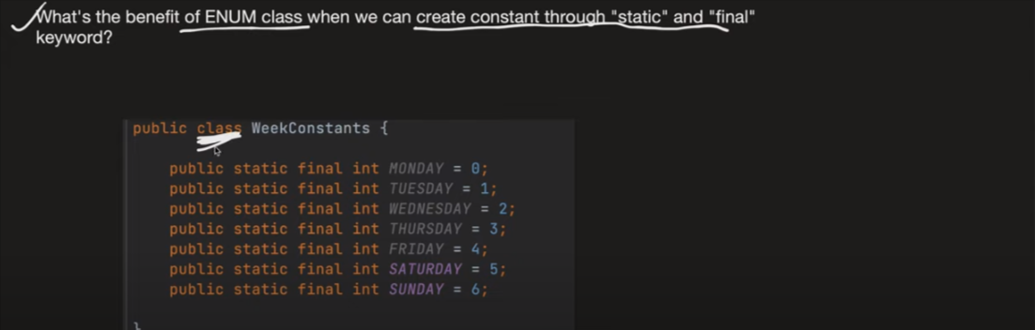

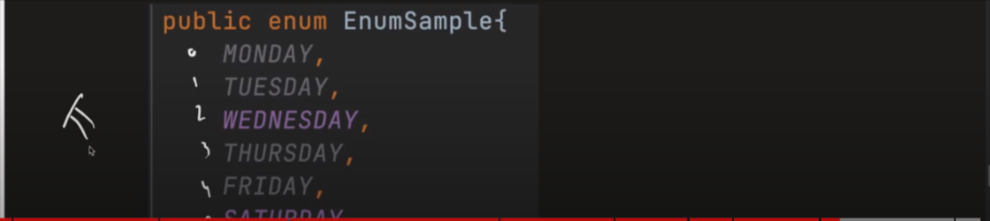

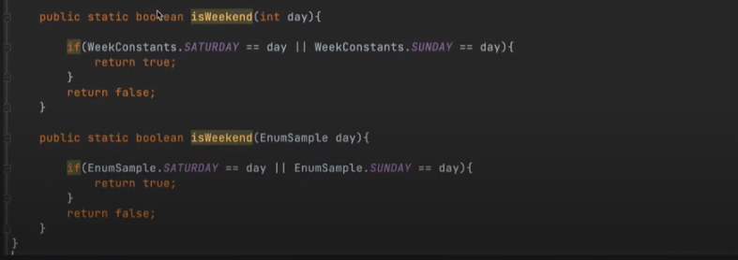

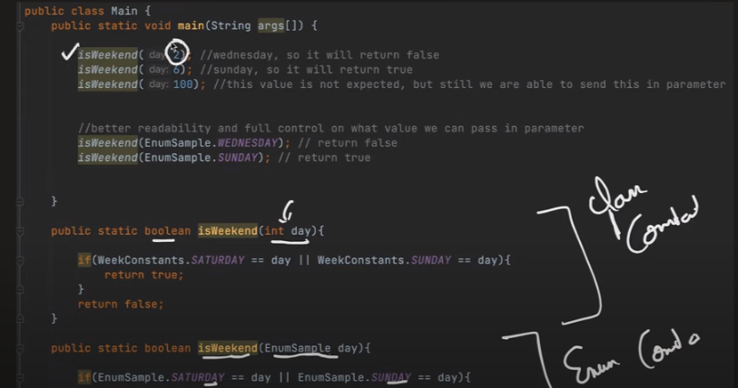

🡺Final Class

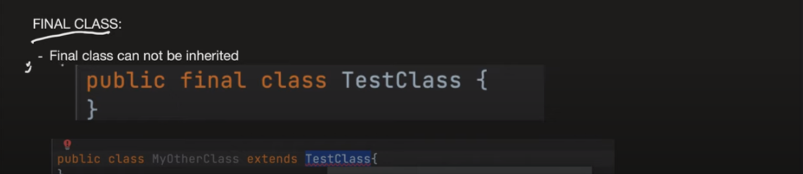

🡺Singleton class

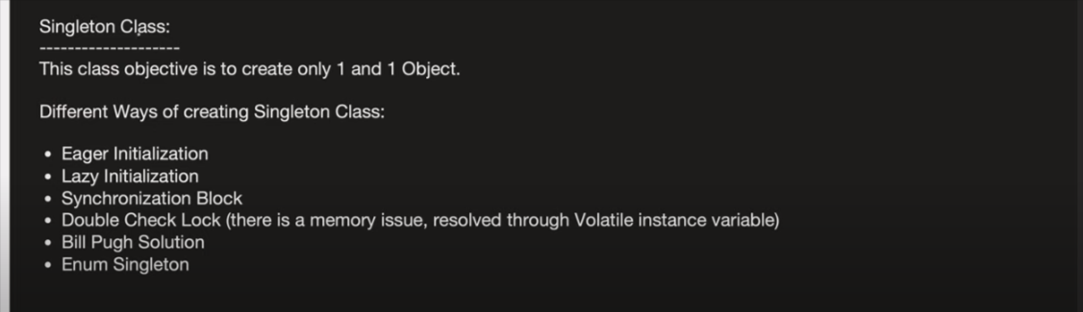

1.Egar intialization

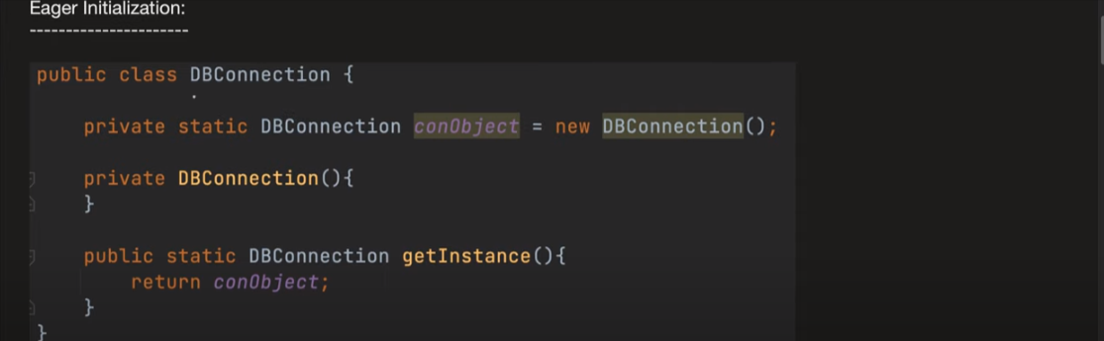

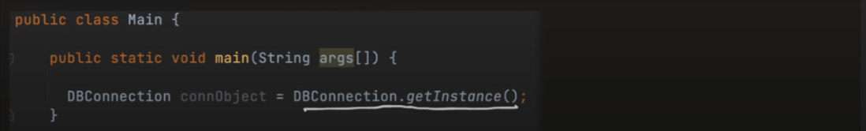

Problem : before using it we have already using memory by creating a object .

2. Lazy intialization

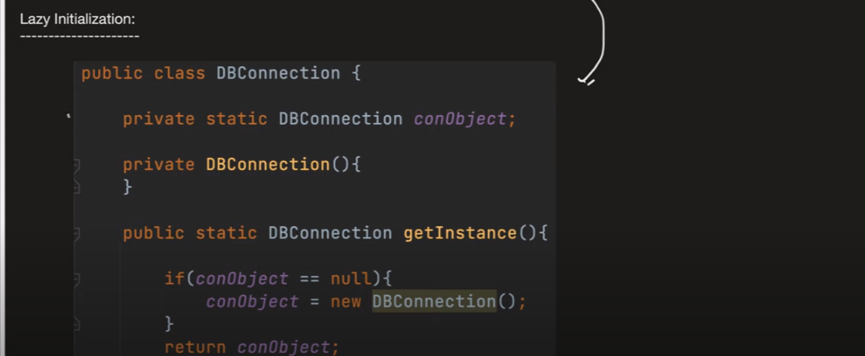

Problem : if multiple Thread coming parlelly then we ended up creating two object .

3.Syncronization Block

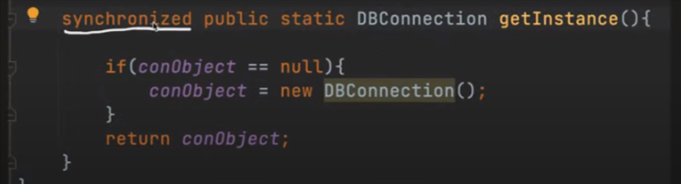

Problem : it will going to take more time because it use lock/unlock.

4.double check lock

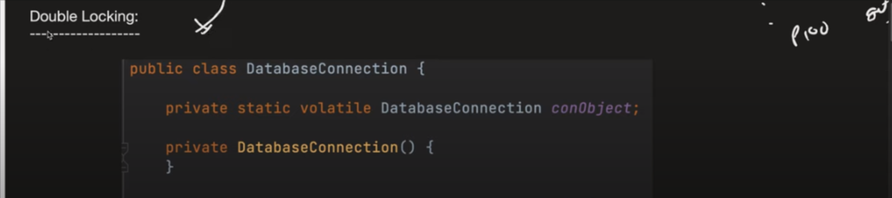

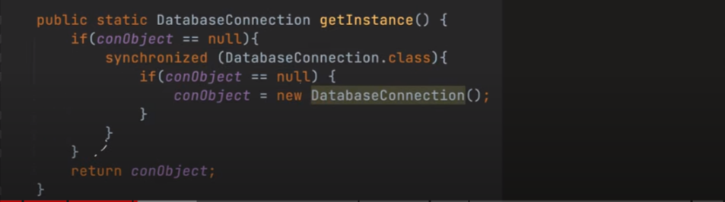

Note : why we use volatile : in cpu we have multiple core , so suppose a thread come to core1 then core1 will going to create a object in there cache memory but still note updated in the main memory again other thread come and go to another core and again create a object in theire chache memory so with the use of volatile new object will going to created in the main memory .

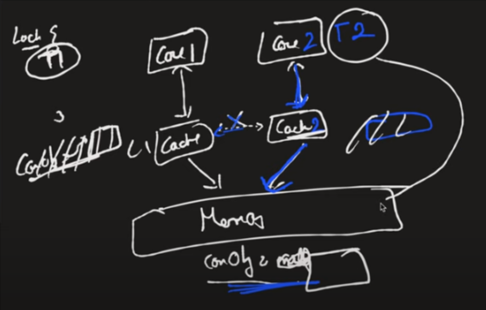

Problem : it is using volatile because of that there will be no cache so it will be slow , it is using syncronized so it will going to use lock/unlock it will also going to take time because of that it will be slow .

5.Bill pub solution

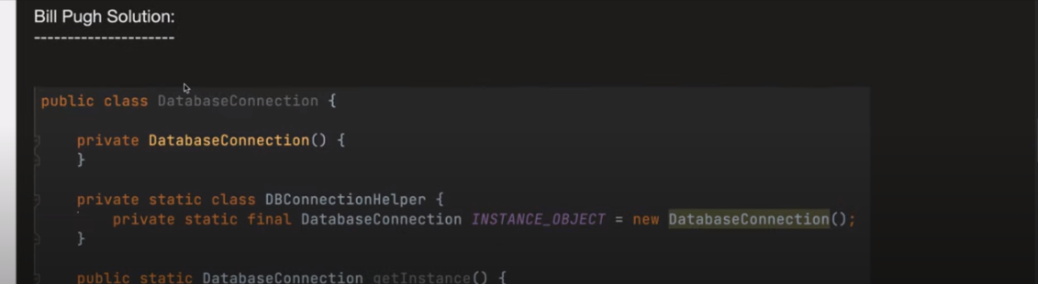

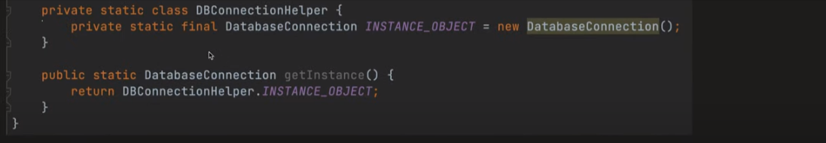

6.Enum singloton

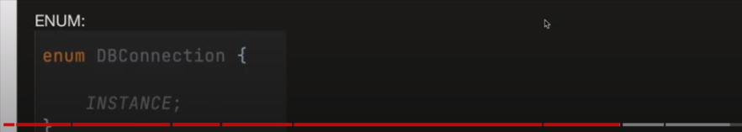

🡺Imutable classes

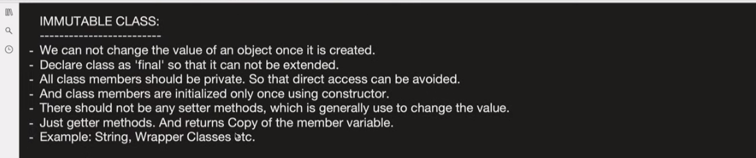

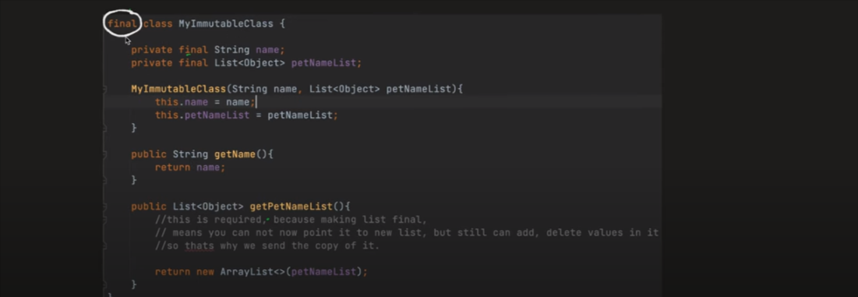

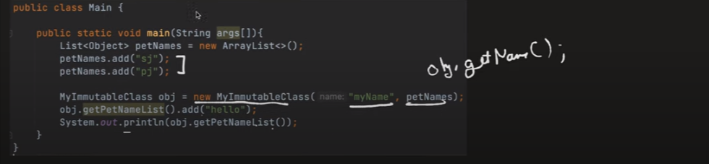

🡺Wrapper class

🡺Interface

Why to inteface :

i)with the interface we can achive abstraction

ii)with the interface we can achive polymorphsim (method overloading)

iii)with the interface we can achive multiple inhetance

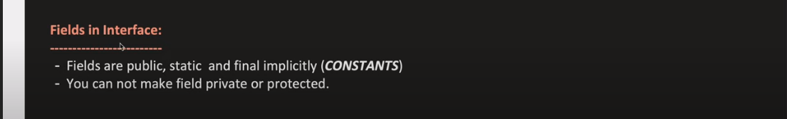

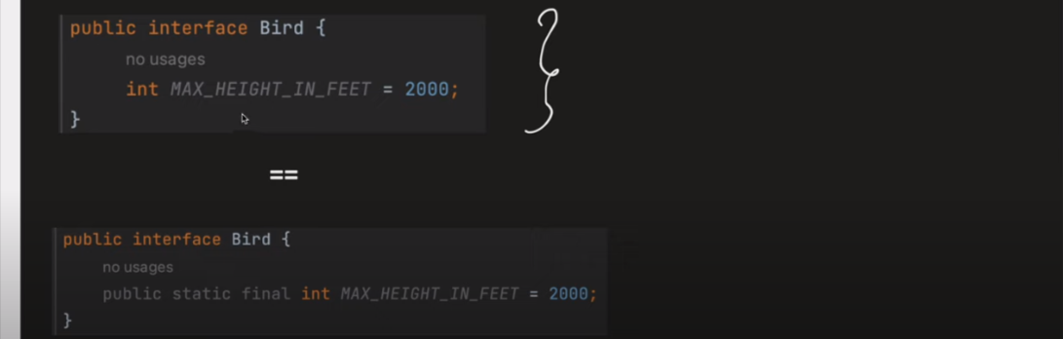

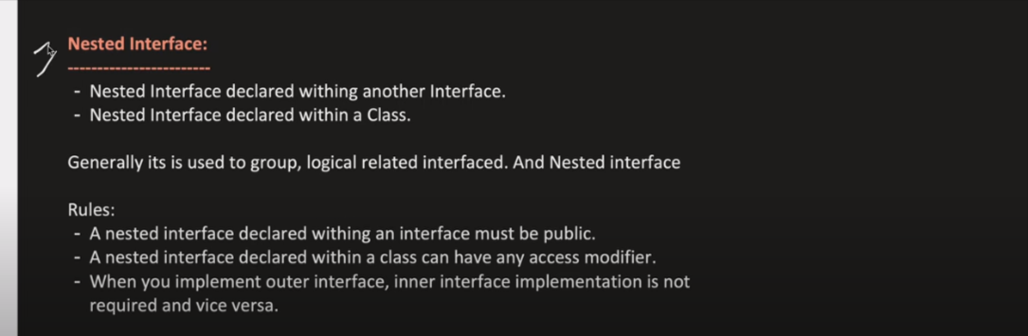

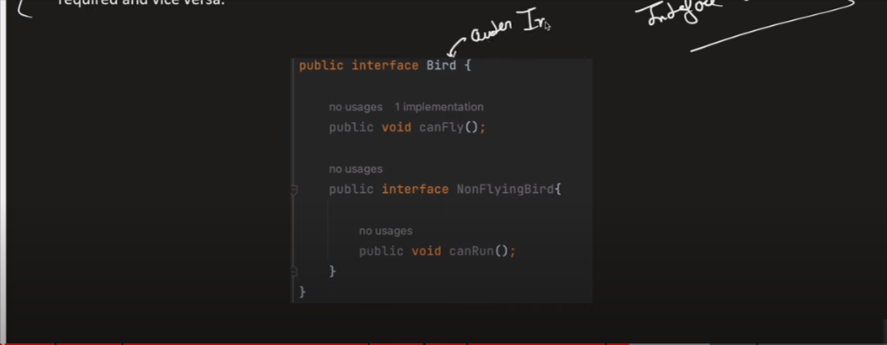

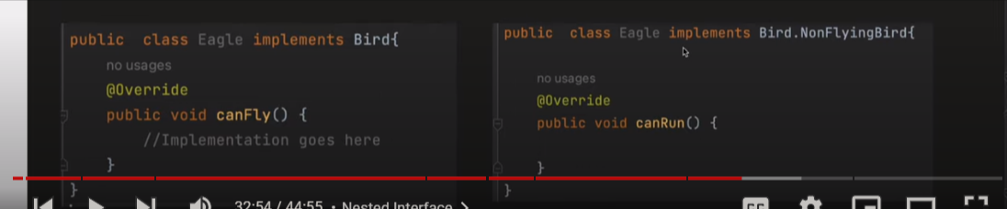

Diffrence between interface and abstract class

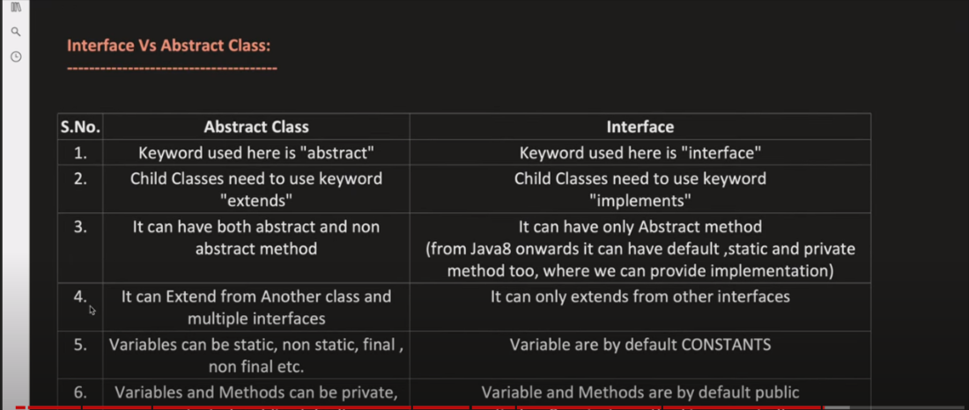

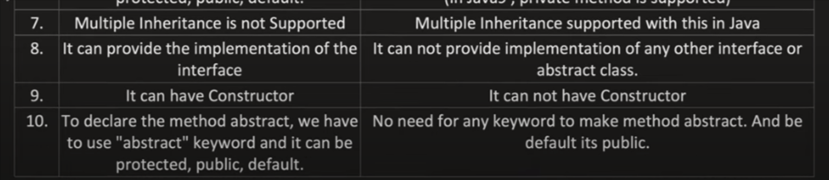

🡺Default method in inteface :

Why :

i)suppose I have interface , it have many child who are implementing it but suppose I have add another mthod in parent interface for that I have to implement this method in all the child class of interface . to solve that issue java8 and java9 comes up with default method ,

🡪with the default method we will be able to implement that method with in the interface

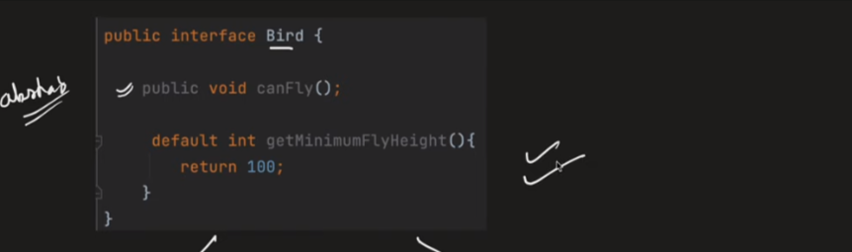

Problem with the default :

Suppose a class is implementing multiple interface all that interface have default method common so the child class will not be able to resolve which default method to use , to solve that issue we have to implement that default method in the child class .

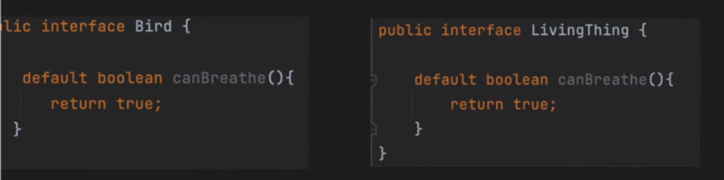

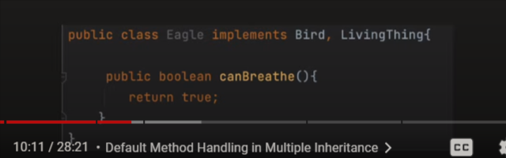

🡺Interface static method

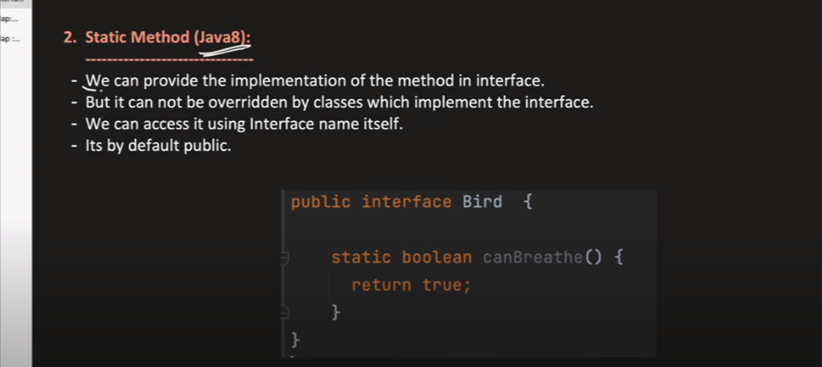

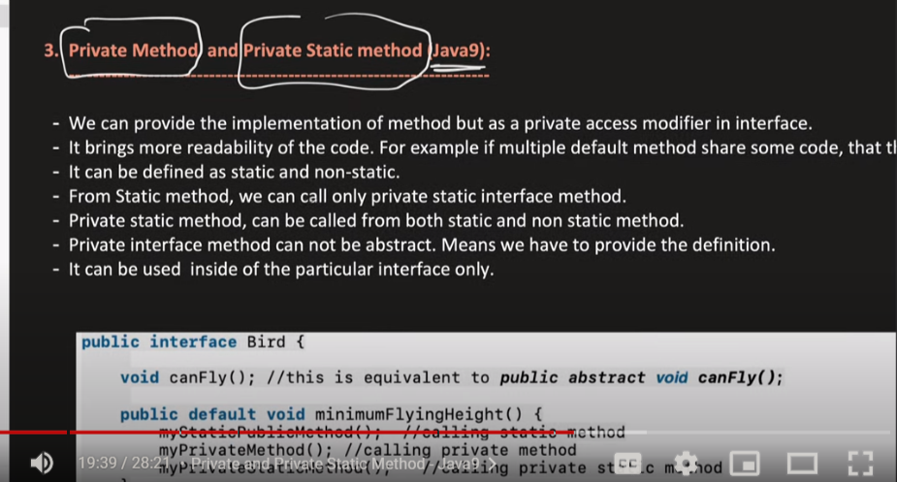

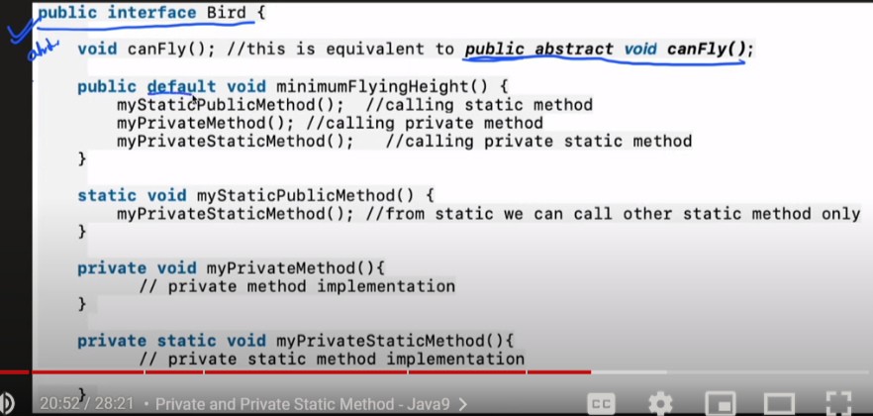

🡺Functional Interface

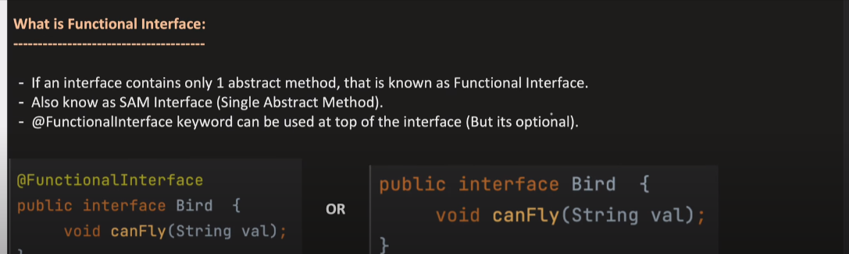

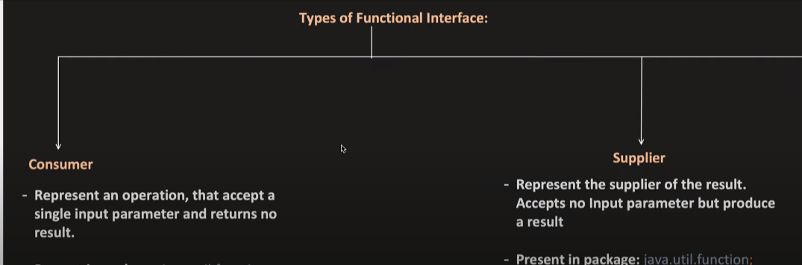

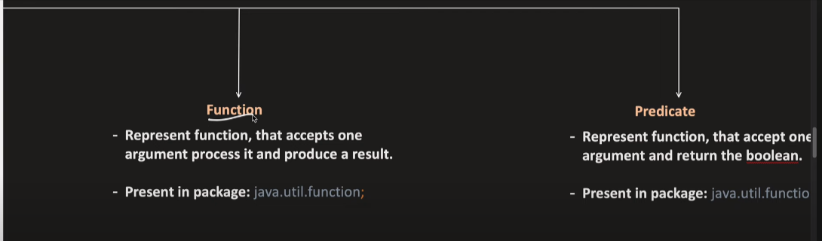

🡪Consumer Interface

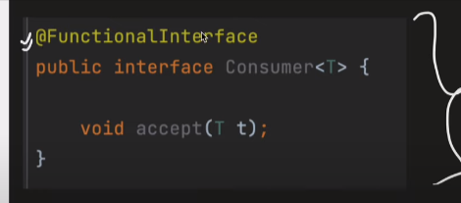

🡪Supplier interface

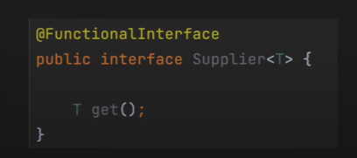

🡪Function Interface

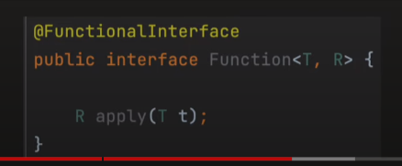

🡪predicate Interface

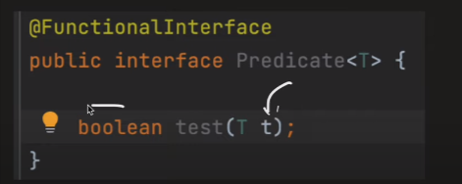

🡪inmplementation

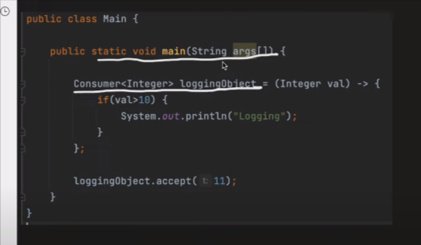

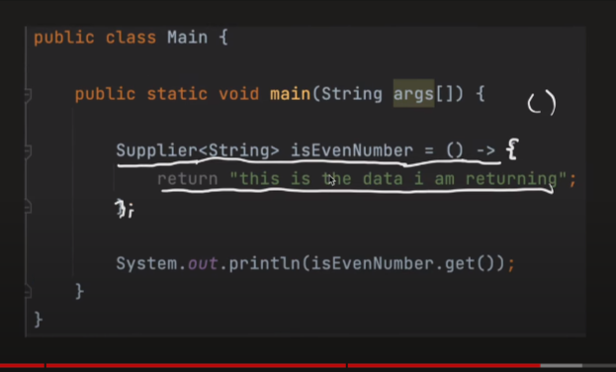

Reflection in JAVA :

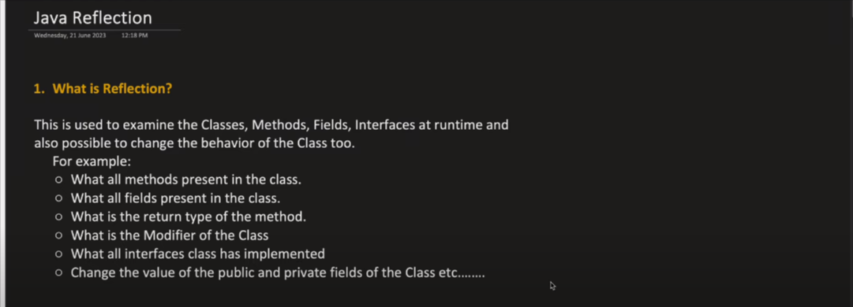

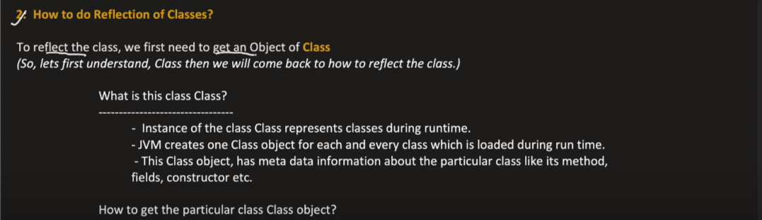

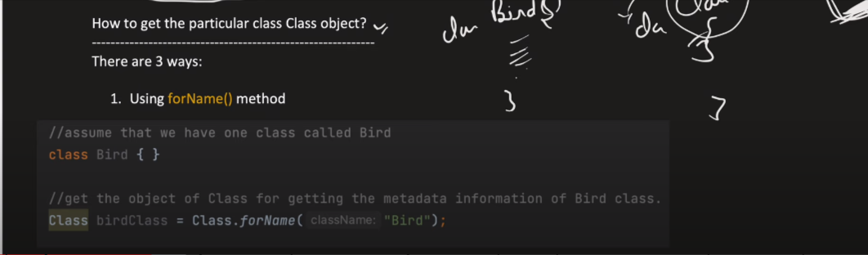

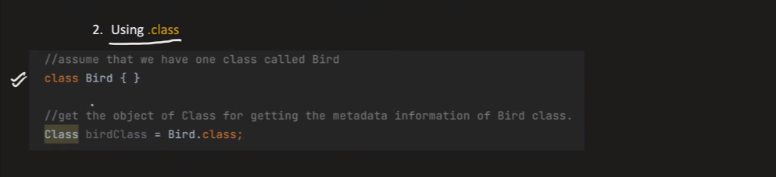

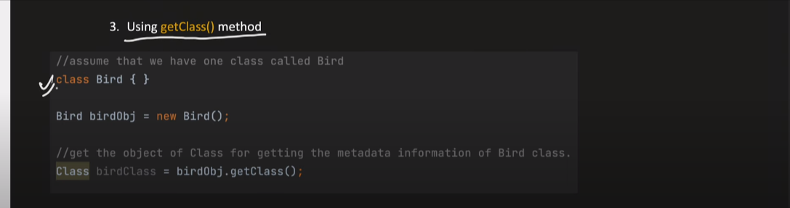

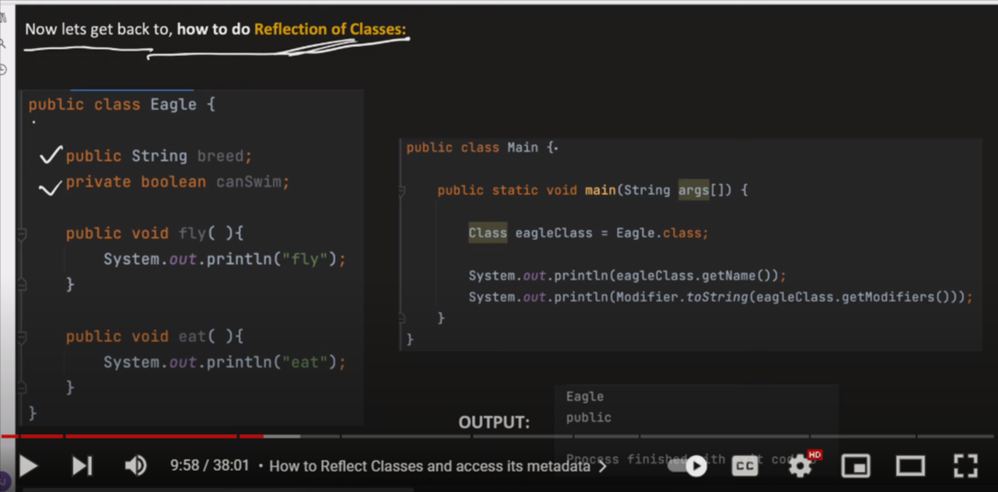



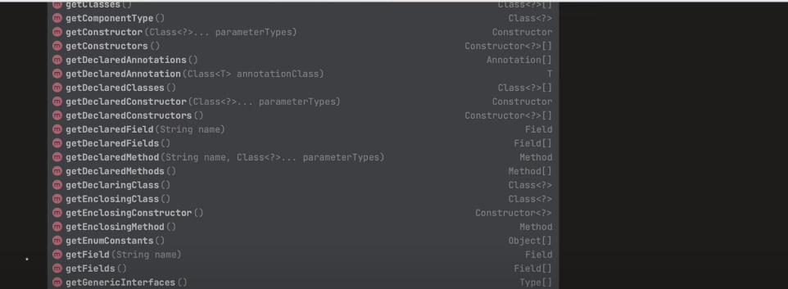

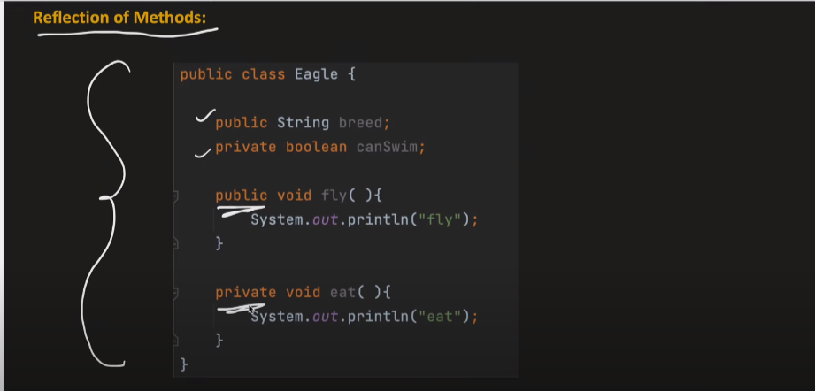

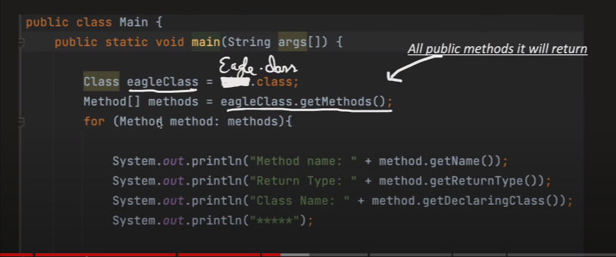

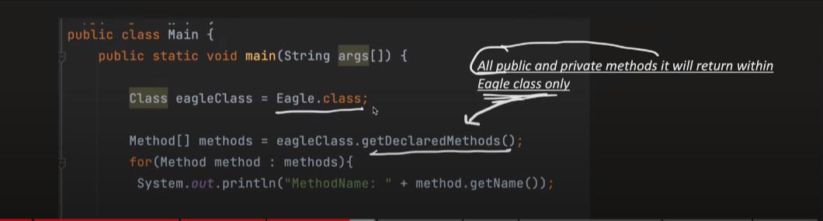

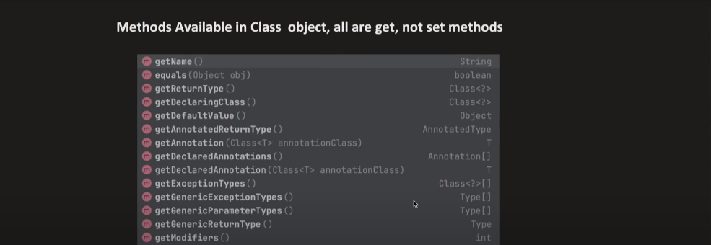

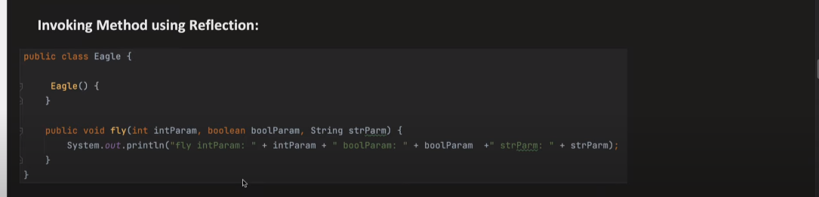

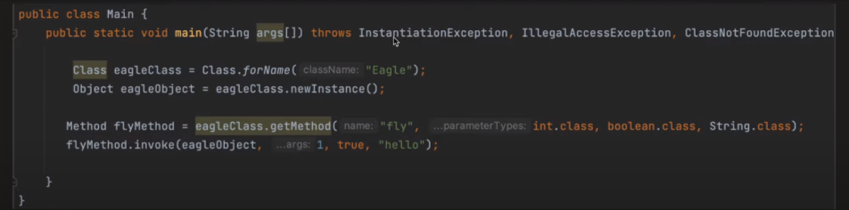

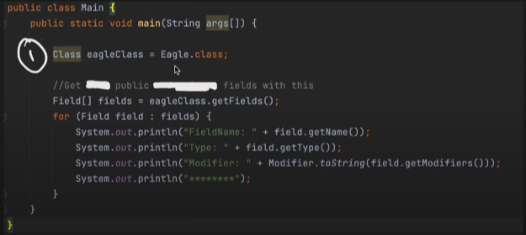

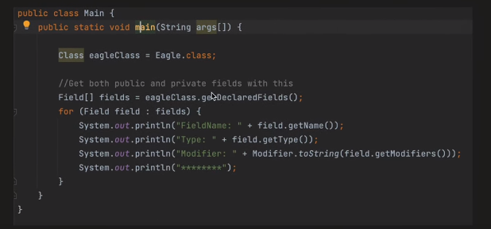

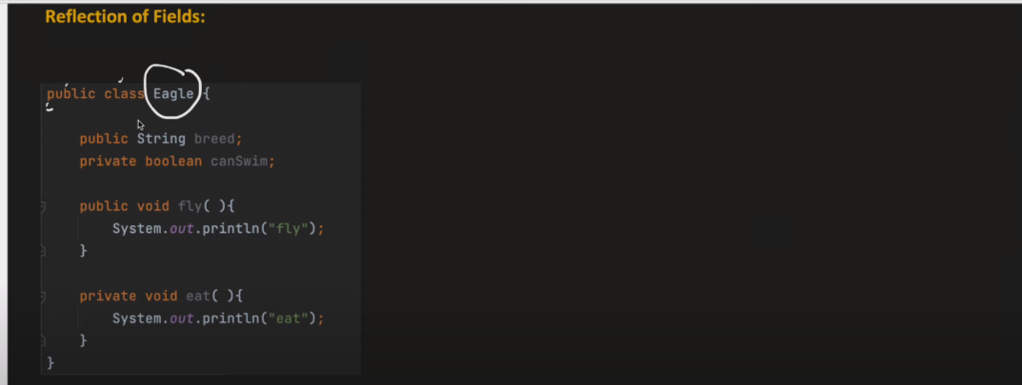

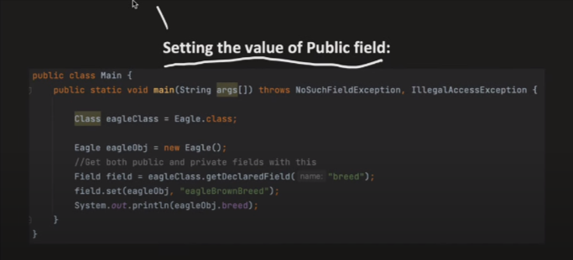

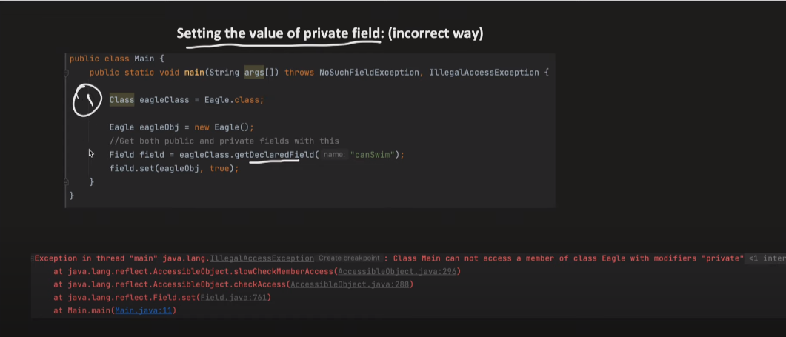

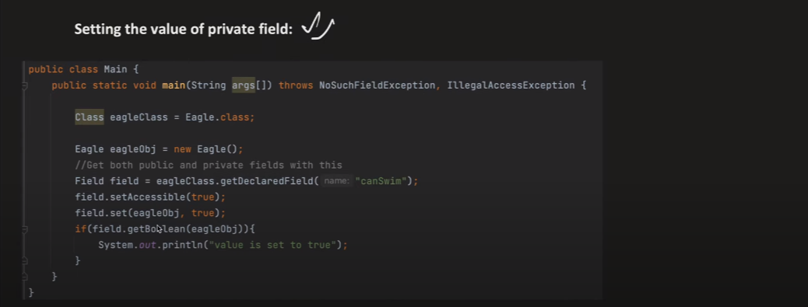

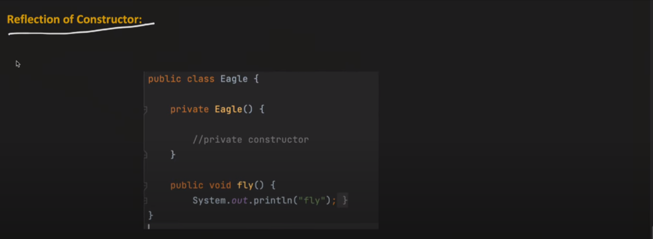

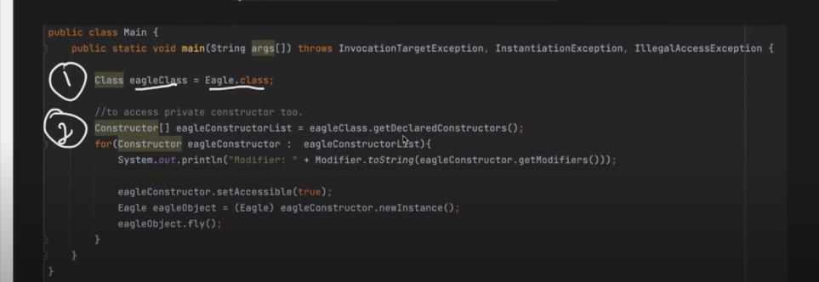

Note :Why we should avoid reflection :

1. It breks the core value of OPPS like ( abstraction , encapsulation ) because we will be able to assess private method and we will be able to modify them as well .
2. Reflection is slow (because every thing in reflaction is happening at run time)

🡺Anotation in java

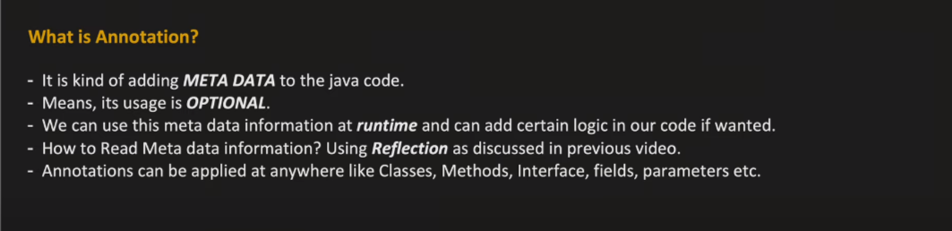

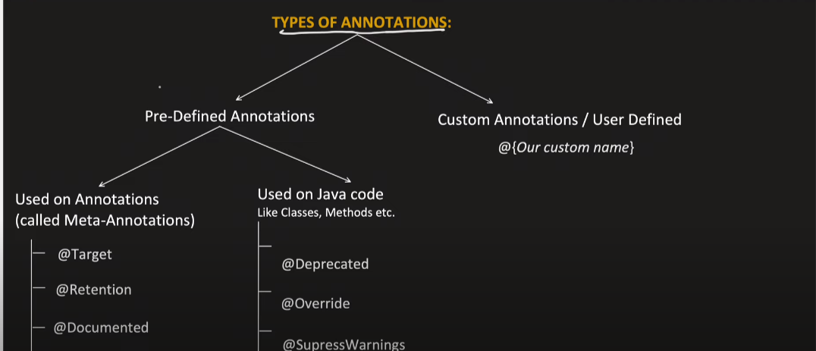

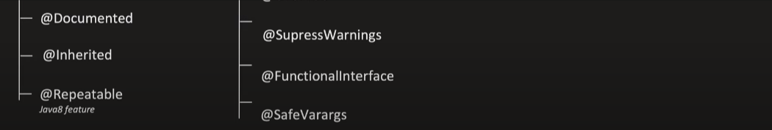

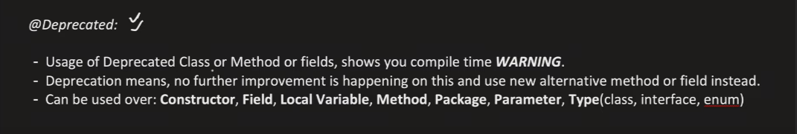

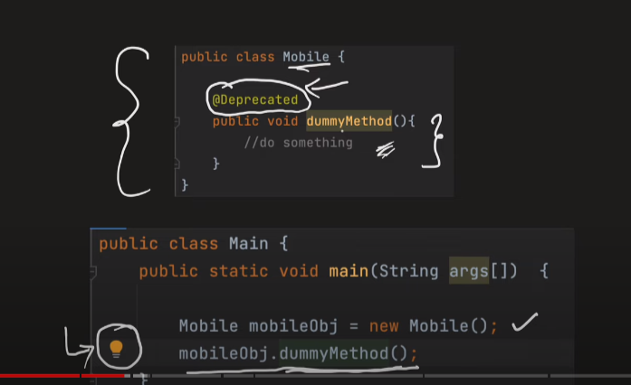

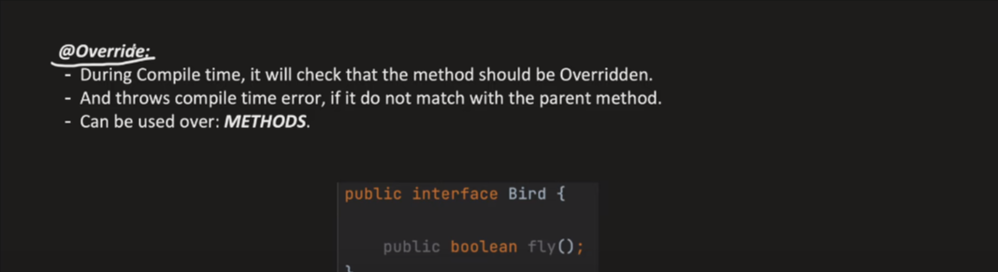

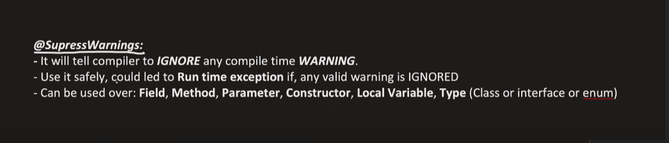

🡪different way of addnig supressWarning anotation

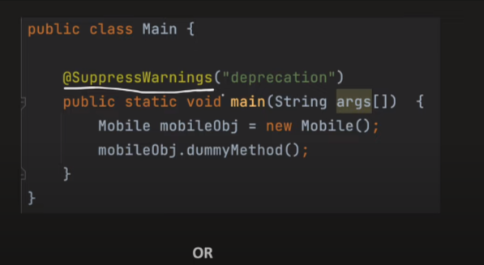

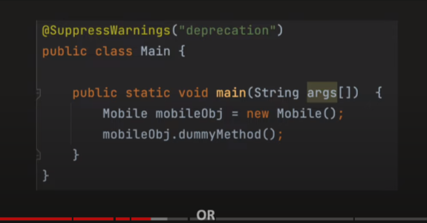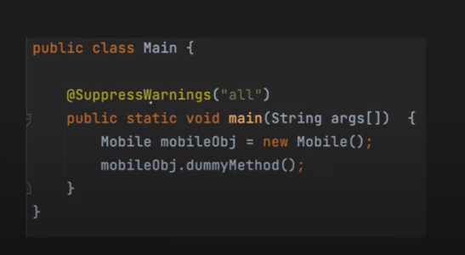

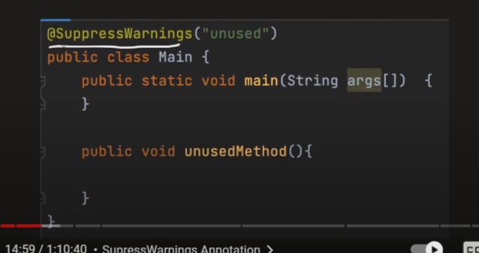

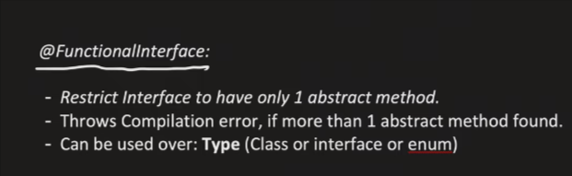

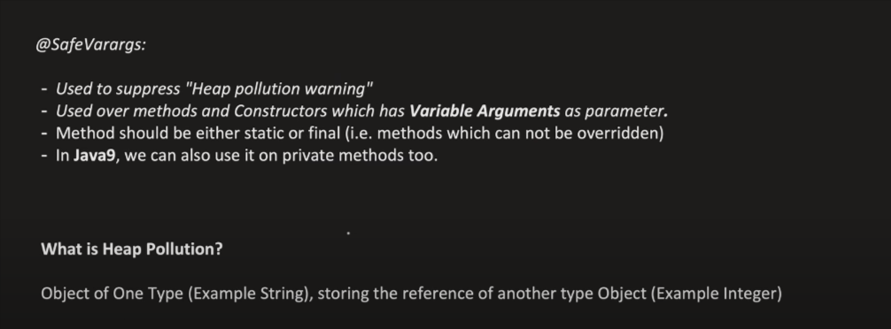

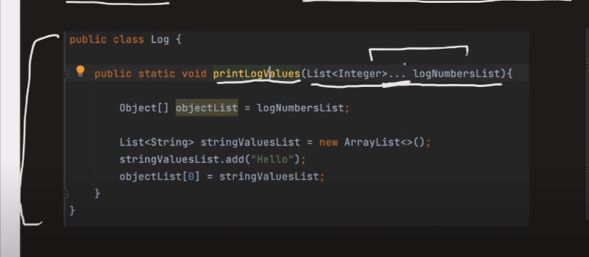



STREAM IN JAVA

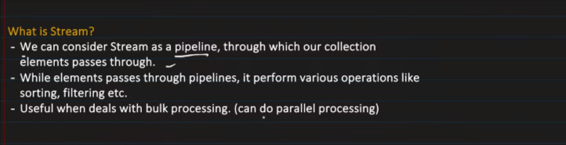

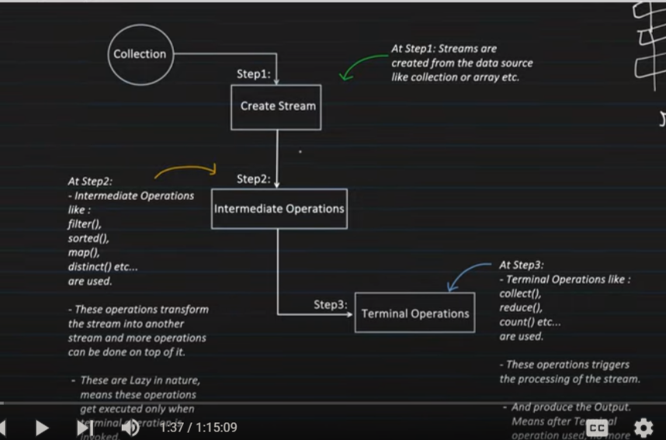

Note : we can have one or multilple intermediate operation but we can only have only terminal operation

